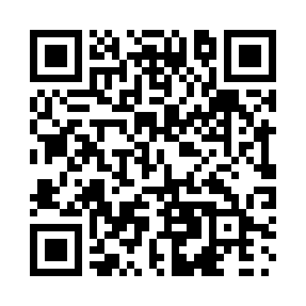
Prayer times for Burmis, Alberta, Canada
Mon 1 Jul 2024 - Wed 31 Jul 2024
High Latitude Method: Angle Based Rule
Prayer Calculation Method: Islamic Society of North America
Asar Calculation Method: Hanafi

Date | Day | Fajr | Sunrise | Dhuhr | Asr | Maghrib | Isha
1 | Mon | 3:38 | 5:35 | 1:41 | 7:13 | 9:47 | 11:44
2 | Tue | 3:38 | 5:36 | 1:41 | 7:13 | 9:47 | 11:44
3 | Wed | 3:39 | 5:36 | 1:42 | 7:13 | 9:47 | 11:44
4 | Thu | 3:39 | 5:37 | 1:42 | 7:12 | 9:46 | 11:44
5 | Fri | 3:40 | 5:38 | 1:42 | 7:12 | 9:46 | 11:44
6 | Sat | 3:40 | 5:39 | 1:42 | 7:12 | 9:45 | 11:44
7 | Sun | 3:41 | 5:40 | 1:42 | 7:12 | 9:45 | 11:43
8 | Mon | 3:41 | 5:40 | 1:42 | 7:12 | 9:44 | 11:43
9 | Tue | 3:42 | 5:41 | 1:43 | 7:11 | 9:43 | 11:43
10 | Wed | 3:42 | 5:42 | 1:43 | 7:11 | 9:43 | 11:43
11 | Thu | 3:43 | 5:43 | 1:43 | 7:11 | 9:42 | 11:42
12 | Fri | 3:44 | 5:44 | 1:43 | 7:10 | 9:41 | 11:42
13 | Sat | 3:44 | 5:45 | 1:43 | 7:10 | 9:40 | 11:41
14 | Sun | 3:45 | 5:46 | 1:43 | 7:09 | 9:39 | 11:41
15 | Mon | 3:45 | 5:48 | 1:43 | 7:09 | 9:38 | 11:41
16 | Tue | 3:46 | 5:49 | 1:43 | 7:09 | 9:37 | 11:40
17 | Wed | 3:46 | 5:50 | 1:43 | 7:08 | 9:36 | 11:40
18 | Thu | 3:47 | 5:51 | 1:43 | 7:07 | 9:35 | 11:39
19 | Fri | 3:48 | 5:52 | 1:44 | 7:07 | 9:34 | 11:39
20 | Sat | 3:48 | 5:53 | 1:44 | 7:06 | 9:33 | 11:38
21 | Sun | 3:49 | 5:55 | 1:44 | 7:06 | 9:32 | 11:38
22 | Mon | 3:50 | 5:56 | 1:44 | 7:05 | 9:31 | 11:37
23 | Tue | 3:51 | 5:57 | 1:44 | 7:04 | 9:30 | 11:35
24 | Wed | 3:54 | 5:58 | 1:44 | 7:04 | 9:28 | 11:33
25 | Thu | 3:56 | 6:00 | 1:44 | 7:03 | 9:27 | 11:30
26 | Fri | 3:58 | 6:01 | 1:44 | 7:02 | 9:26 | 11:28
27 | Sat | 4:01 | 6:02 | 1:44 | 7:01 | 9:24 | 11:25
28 | Sun | 4:03 | 6:04 | 1:44 | 7:00 | 9:23 | 11:23
29 | Mon | 4:05 | 6:05 | 1:44 | 7:00 | 9:22 | 11:20
30 | Tue | 4:08 | 6:06 | 1:44 | 6:59 | 9:20 | 11:18
31 | Wed | 4:10 | 6:08 | 1:44 | 6:58 | 9:19 | 11:16
Prayer times provided by https://www.salahtimes.com

