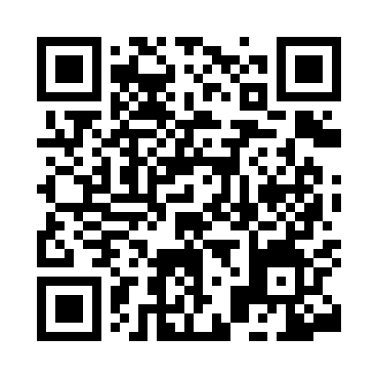
Prayer times for Albi, Italy
Mon 1 Apr 2024 - Tue 30 Apr 2024
High Latitude Method: Angle Based Rule
Prayer Calculation Method: Muslim World League
Asar Calculation Method: Hanafi

Date | Day | Fajr | Sunrise | Dhuhr | Asr | Maghrib | Isha
1 | Mon | 5:06 | 6:38 | 12:57 | 5:27 | 7:18 | 8:44
2 | Tue | 5:05 | 6:36 | 12:57 | 5:28 | 7:19 | 8:45
3 | Wed | 5:03 | 6:35 | 12:57 | 5:29 | 7:20 | 8:46
4 | Thu | 5:01 | 6:33 | 12:56 | 5:29 | 7:21 | 8:47
5 | Fri | 4:59 | 6:32 | 12:56 | 5:30 | 7:21 | 8:48
6 | Sat | 4:57 | 6:30 | 12:56 | 5:30 | 7:22 | 8:50
7 | Sun | 4:56 | 6:28 | 12:56 | 5:31 | 7:23 | 8:51
8 | Mon | 4:54 | 6:27 | 12:55 | 5:32 | 7:24 | 8:52
9 | Tue | 4:52 | 6:25 | 12:55 | 5:32 | 7:25 | 8:53
10 | Wed | 4:50 | 6:24 | 12:55 | 5:33 | 7:26 | 8:54
11 | Thu | 4:48 | 6:22 | 12:55 | 5:33 | 7:27 | 8:56
12 | Fri | 4:47 | 6:21 | 12:54 | 5:34 | 7:28 | 8:57
13 | Sat | 4:45 | 6:19 | 12:54 | 5:35 | 7:29 | 8:58
14 | Sun | 4:43 | 6:18 | 12:54 | 5:35 | 7:30 | 8:59
15 | Mon | 4:41 | 6:17 | 12:54 | 5:36 | 7:31 | 9:01
16 | Tue | 4:40 | 6:15 | 12:53 | 5:36 | 7:32 | 9:02
17 | Wed | 4:38 | 6:14 | 12:53 | 5:37 | 7:33 | 9:03
18 | Thu | 4:36 | 6:12 | 12:53 | 5:37 | 7:34 | 9:05
19 | Fri | 4:34 | 6:11 | 12:53 | 5:38 | 7:35 | 9:06
20 | Sat | 4:33 | 6:09 | 12:52 | 5:39 | 7:36 | 9:07
21 | Sun | 4:31 | 6:08 | 12:52 | 5:39 | 7:37 | 9:08
22 | Mon | 4:29 | 6:07 | 12:52 | 5:40 | 7:38 | 9:10
23 | Tue | 4:27 | 6:05 | 12:52 | 5:40 | 7:39 | 9:11
24 | Wed | 4:26 | 6:04 | 12:52 | 5:41 | 7:40 | 9:12
25 | Thu | 4:24 | 6:03 | 12:52 | 5:41 | 7:41 | 9:14
26 | Fri | 4:22 | 6:01 | 12:51 | 5:42 | 7:42 | 9:15
27 | Sat | 4:20 | 6:00 | 12:51 | 5:42 | 7:43 | 9:16
28 | Sun | 4:19 | 5:59 | 12:51 | 5:43 | 7:44 | 9:18
29 | Mon | 4:17 | 5:58 | 12:51 | 5:44 | 7:45 | 9:19
30 | Tue | 4:15 | 5:56 | 12:51 | 5:44 | 7:46 | 9:21
Prayer times provided by https://www.salahtimes.com

