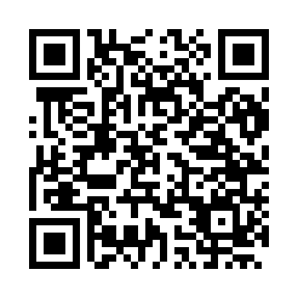
Prayer times for Lonny, France
Wed 1 May 2024 - Fri 31 May 2024
High Latitude Method: Angle Based Rule
Prayer Calculation Method: Islamic Organisations Union of France
Asar Calculation Method: Shafi

Date | Day | Fajr | Sunrise | Dhuhr | Asr | Maghrib | Isha
1 | Wed | 4:55 | 6:18 | 1:39 | 5:40 | 9:00 | 10:24
2 | Thu | 4:52 | 6:16 | 1:39 | 5:41 | 9:02 | 10:26
3 | Fri | 4:50 | 6:14 | 1:38 | 5:41 | 9:03 | 10:28
4 | Sat | 4:48 | 6:13 | 1:38 | 5:42 | 9:05 | 10:30
5 | Sun | 4:46 | 6:11 | 1:38 | 5:42 | 9:06 | 10:32
6 | Mon | 4:43 | 6:09 | 1:38 | 5:43 | 9:08 | 10:34
7 | Tue | 4:41 | 6:08 | 1:38 | 5:44 | 9:09 | 10:36
8 | Wed | 4:39 | 6:06 | 1:38 | 5:44 | 9:11 | 10:38
9 | Thu | 4:37 | 6:05 | 1:38 | 5:45 | 9:12 | 10:40
10 | Fri | 4:35 | 6:03 | 1:38 | 5:45 | 9:14 | 10:42
11 | Sat | 4:33 | 6:02 | 1:38 | 5:46 | 9:15 | 10:45
12 | Sun | 4:31 | 6:00 | 1:38 | 5:46 | 9:17 | 10:47
13 | Mon | 4:28 | 5:59 | 1:38 | 5:47 | 9:18 | 10:49
14 | Tue | 4:26 | 5:57 | 1:38 | 5:47 | 9:20 | 10:51
15 | Wed | 4:24 | 5:56 | 1:38 | 5:48 | 9:21 | 10:53
16 | Thu | 4:22 | 5:54 | 1:38 | 5:49 | 9:22 | 10:55
17 | Fri | 4:20 | 5:53 | 1:38 | 5:49 | 9:24 | 10:57
18 | Sat | 4:18 | 5:52 | 1:38 | 5:50 | 9:25 | 10:59
19 | Sun | 4:17 | 5:51 | 1:38 | 5:50 | 9:26 | 11:01
20 | Mon | 4:15 | 5:49 | 1:38 | 5:51 | 9:28 | 11:03
21 | Tue | 4:13 | 5:48 | 1:38 | 5:51 | 9:29 | 11:05
22 | Wed | 4:11 | 5:47 | 1:38 | 5:52 | 9:30 | 11:07
23 | Thu | 4:09 | 5:46 | 1:38 | 5:52 | 9:31 | 11:09
24 | Fri | 4:08 | 5:45 | 1:39 | 5:53 | 9:33 | 11:10
25 | Sat | 4:06 | 5:44 | 1:39 | 5:53 | 9:34 | 11:12
26 | Sun | 4:05 | 5:43 | 1:39 | 5:54 | 9:35 | 11:13
27 | Mon | 4:05 | 5:42 | 1:39 | 5:54 | 9:36 | 11:13
28 | Tue | 4:04 | 5:41 | 1:39 | 5:54 | 9:37 | 11:14
29 | Wed | 4:04 | 5:40 | 1:39 | 5:55 | 9:38 | 11:15
30 | Thu | 4:04 | 5:40 | 1:39 | 5:55 | 9:39 | 11:15
31 | Fri | 4:03 | 5:39 | 1:39 | 5:56 | 9:41 | 11:16
Prayer times provided by https://www.salahtimes.com

