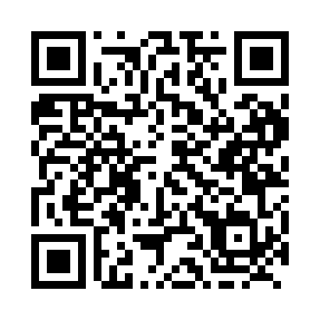
Prayer times for Aishihik, Yukon, Canada
Wed 1 May 2024 - Fri 31 May 2024
High Latitude Method: Angle Based Rule
Prayer Calculation Method: Islamic Society of North America
Asar Calculation Method: Hanafi

Date | Day | Fajr | Sunrise | Dhuhr | Asr | Maghrib | Isha
1 | Wed | 4:02 | 5:56 | 2:07 | 7:28 | 10:19 | 12:13
2 | Thu | 4:01 | 5:54 | 2:07 | 7:29 | 10:22 | 12:15
3 | Fri | 3:59 | 5:51 | 2:07 | 7:31 | 10:24 | 12:16
4 | Sat | 3:58 | 5:48 | 2:07 | 7:32 | 10:27 | 12:17
5 | Sun | 3:56 | 5:45 | 2:07 | 7:34 | 10:30 | 12:19
6 | Mon | 3:55 | 5:42 | 2:07 | 7:35 | 10:33 | 12:20
7 | Tue | 3:53 | 5:39 | 2:07 | 7:37 | 10:35 | 12:21
8 | Wed | 3:52 | 5:36 | 2:06 | 7:38 | 10:38 | 12:23
9 | Thu | 3:50 | 5:34 | 2:06 | 7:40 | 10:41 | 12:24
10 | Fri | 3:49 | 5:31 | 2:06 | 7:41 | 10:43 | 12:25
11 | Sat | 3:48 | 5:28 | 2:06 | 7:43 | 10:46 | 12:27
12 | Sun | 3:46 | 5:25 | 2:06 | 7:44 | 10:49 | 12:28
13 | Mon | 3:45 | 5:23 | 2:06 | 7:45 | 10:51 | 12:29
14 | Tue | 3:44 | 5:20 | 2:06 | 7:47 | 10:54 | 12:31
15 | Wed | 3:42 | 5:18 | 2:06 | 7:48 | 10:57 | 12:32
16 | Thu | 3:41 | 5:15 | 2:06 | 7:49 | 10:59 | 12:33
17 | Fri | 3:40 | 5:12 | 2:06 | 7:51 | 11:02 | 12:34
18 | Sat | 3:39 | 5:10 | 2:07 | 7:52 | 11:04 | 12:36
19 | Sun | 3:37 | 5:08 | 2:07 | 7:53 | 11:07 | 12:37
20 | Mon | 3:36 | 5:05 | 2:07 | 7:54 | 11:09 | 12:38
21 | Tue | 3:35 | 5:03 | 2:07 | 7:56 | 11:12 | 12:40
22 | Wed | 3:34 | 5:00 | 2:07 | 7:57 | 11:14 | 12:41
23 | Thu | 3:33 | 4:58 | 2:07 | 7:58 | 11:17 | 12:42
24 | Fri | 3:32 | 4:56 | 2:07 | 7:59 | 11:19 | 12:43
25 | Sat | 3:31 | 4:54 | 2:07 | 8:00 | 11:21 | 12:45
26 | Sun | 3:30 | 4:52 | 2:07 | 8:01 | 11:24 | 12:46
27 | Mon | 3:29 | 4:50 | 2:07 | 8:02 | 11:26 | 12:47
28 | Tue | 3:28 | 4:48 | 2:07 | 8:03 | 11:28 | 12:48
29 | Wed | 3:27 | 4:46 | 2:08 | 8:04 | 11:30 | 12:49
30 | Thu | 3:26 | 4:44 | 2:08 | 8:05 | 11:32 | 12:50
31 | Fri | 3:25 | 4:42 | 2:08 | 8:06 | 11:34 | 12:51
Prayer times provided by https://www.salahtimes.com

