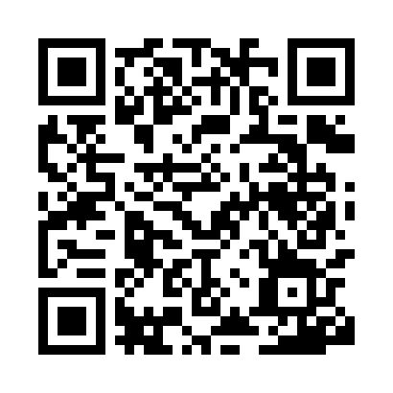
Prayer times for Belovitsa, Bulgaria
Mon 1 Apr 2024 - Tue 30 Apr 2024
High Latitude Method: Angle Based Rule
Prayer Calculation Method: Muslim World League
Asar Calculation Method: Hanafi

Date | Day | Fajr | Sunrise | Dhuhr | Asr | Maghrib | Isha
1 | Mon | 5:27 | 7:04 | 1:26 | 5:55 | 7:48 | 9:19
2 | Tue | 5:25 | 7:02 | 1:25 | 5:56 | 7:49 | 9:21
3 | Wed | 5:23 | 7:00 | 1:25 | 5:57 | 7:50 | 9:22
4 | Thu | 5:21 | 6:59 | 1:25 | 5:57 | 7:51 | 9:23
5 | Fri | 5:19 | 6:57 | 1:24 | 5:58 | 7:53 | 9:25
6 | Sat | 5:17 | 6:55 | 1:24 | 5:59 | 7:54 | 9:26
7 | Sun | 5:15 | 6:54 | 1:24 | 6:00 | 7:55 | 9:28
8 | Mon | 5:13 | 6:52 | 1:24 | 6:00 | 7:56 | 9:29
9 | Tue | 5:11 | 6:50 | 1:23 | 6:01 | 7:57 | 9:31
10 | Wed | 5:09 | 6:49 | 1:23 | 6:02 | 7:58 | 9:32
11 | Thu | 5:07 | 6:47 | 1:23 | 6:03 | 7:59 | 9:33
12 | Fri | 5:05 | 6:45 | 1:23 | 6:03 | 8:01 | 9:35
13 | Sat | 5:03 | 6:44 | 1:22 | 6:04 | 8:02 | 9:36
14 | Sun | 5:01 | 6:42 | 1:22 | 6:05 | 8:03 | 9:38
15 | Mon | 4:59 | 6:40 | 1:22 | 6:06 | 8:04 | 9:39
16 | Tue | 4:57 | 6:39 | 1:22 | 6:06 | 8:05 | 9:41
17 | Wed | 4:55 | 6:37 | 1:21 | 6:07 | 8:06 | 9:42
18 | Thu | 4:53 | 6:36 | 1:21 | 6:08 | 8:07 | 9:44
19 | Fri | 4:51 | 6:34 | 1:21 | 6:08 | 8:08 | 9:46
20 | Sat | 4:49 | 6:33 | 1:21 | 6:09 | 8:10 | 9:47
21 | Sun | 4:47 | 6:31 | 1:20 | 6:10 | 8:11 | 9:49
22 | Mon | 4:45 | 6:29 | 1:20 | 6:10 | 8:12 | 9:50
23 | Tue | 4:43 | 6:28 | 1:20 | 6:11 | 8:13 | 9:52
24 | Wed | 4:41 | 6:26 | 1:20 | 6:12 | 8:14 | 9:53
25 | Thu | 4:39 | 6:25 | 1:20 | 6:12 | 8:15 | 9:55
26 | Fri | 4:37 | 6:24 | 1:20 | 6:13 | 8:16 | 9:57
27 | Sat | 4:35 | 6:22 | 1:19 | 6:14 | 8:17 | 9:58
28 | Sun | 4:33 | 6:21 | 1:19 | 6:14 | 8:19 | 10:00
29 | Mon | 4:31 | 6:19 | 1:19 | 6:15 | 8:20 | 10:01
30 | Tue | 4:29 | 6:18 | 1:19 | 6:16 | 8:21 | 10:03
Prayer times provided by https://www.salahtimes.com

