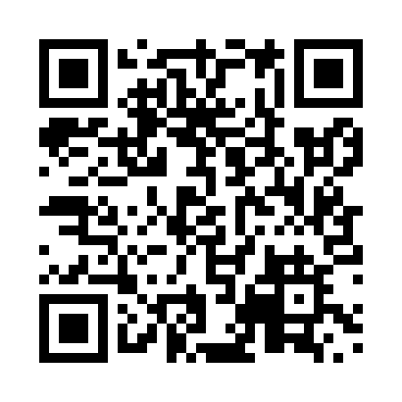
Prayer times for Kynocks, Yukon, Canada
Wed 1 May 2024 - Fri 31 May 2024
High Latitude Method: Angle Based Rule
Prayer Calculation Method: Islamic Society of North America
Asar Calculation Method: Hanafi

Date | Day | Fajr | Sunrise | Dhuhr | Asr | Maghrib | Isha
1 | Wed | 3:57 | 5:52 | 2:01 | 7:21 | 10:11 | 12:06
2 | Thu | 3:55 | 5:49 | 2:01 | 7:23 | 10:13 | 12:07
3 | Fri | 3:54 | 5:47 | 2:01 | 7:24 | 10:16 | 12:09
4 | Sat | 3:53 | 5:44 | 2:01 | 7:26 | 10:19 | 12:10
5 | Sun | 3:51 | 5:41 | 2:01 | 7:27 | 10:21 | 12:11
6 | Mon | 3:50 | 5:38 | 2:00 | 7:29 | 10:24 | 12:13
7 | Tue | 3:48 | 5:35 | 2:00 | 7:30 | 10:27 | 12:14
8 | Wed | 3:47 | 5:33 | 2:00 | 7:31 | 10:29 | 12:15
9 | Thu | 3:45 | 5:30 | 2:00 | 7:33 | 10:32 | 12:16
10 | Fri | 3:44 | 5:27 | 2:00 | 7:34 | 10:35 | 12:18
11 | Sat | 3:43 | 5:25 | 2:00 | 7:36 | 10:37 | 12:19
12 | Sun | 3:41 | 5:22 | 2:00 | 7:37 | 10:40 | 12:20
13 | Mon | 3:40 | 5:19 | 2:00 | 7:38 | 10:42 | 12:22
14 | Tue | 3:39 | 5:17 | 2:00 | 7:40 | 10:45 | 12:23
15 | Wed | 3:38 | 5:14 | 2:00 | 7:41 | 10:48 | 12:24
16 | Thu | 3:36 | 5:12 | 2:00 | 7:42 | 10:50 | 12:26
17 | Fri | 3:35 | 5:09 | 2:00 | 7:44 | 10:53 | 12:27
18 | Sat | 3:34 | 5:07 | 2:00 | 7:45 | 10:55 | 12:28
19 | Sun | 3:33 | 5:04 | 2:00 | 7:46 | 10:58 | 12:29
20 | Mon | 3:32 | 5:02 | 2:00 | 7:47 | 11:00 | 12:31
21 | Tue | 3:31 | 5:00 | 2:01 | 7:49 | 11:02 | 12:32
22 | Wed | 3:29 | 4:58 | 2:01 | 7:50 | 11:05 | 12:33
23 | Thu | 3:28 | 4:55 | 2:01 | 7:51 | 11:07 | 12:34
24 | Fri | 3:27 | 4:53 | 2:01 | 7:52 | 11:09 | 12:35
25 | Sat | 3:26 | 4:51 | 2:01 | 7:53 | 11:12 | 12:37
26 | Sun | 3:25 | 4:49 | 2:01 | 7:54 | 11:14 | 12:38
27 | Mon | 3:24 | 4:47 | 2:01 | 7:55 | 11:16 | 12:39
28 | Tue | 3:24 | 4:45 | 2:01 | 7:56 | 11:18 | 12:40
29 | Wed | 3:23 | 4:43 | 2:01 | 7:57 | 11:20 | 12:41
30 | Thu | 3:22 | 4:42 | 2:02 | 7:58 | 11:22 | 12:42
31 | Fri | 3:21 | 4:40 | 2:02 | 7:59 | 11:24 | 12:43
Prayer times provided by https://www.salahtimes.com

