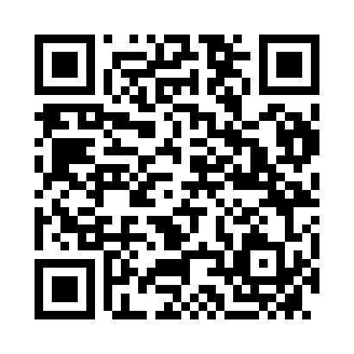
Prayer times for Nußbach, Austria
Wed 1 May 2024 - Fri 31 May 2024
High Latitude Method: Angle Based Rule
Prayer Calculation Method: Muslim World League
Asar Calculation Method: Shafi

Date | Day | Fajr | Sunrise | Dhuhr | Asr | Maghrib | Isha
1 | Wed | 3:35 | 5:45 | 1:00 | 5:00 | 8:17 | 10:18
2 | Thu | 3:33 | 5:43 | 1:00 | 5:00 | 8:18 | 10:20
3 | Fri | 3:30 | 5:42 | 1:00 | 5:01 | 8:20 | 10:22
4 | Sat | 3:27 | 5:40 | 1:00 | 5:01 | 8:21 | 10:25
5 | Sun | 3:25 | 5:38 | 1:00 | 5:02 | 8:22 | 10:27
6 | Mon | 3:22 | 5:37 | 1:00 | 5:03 | 8:24 | 10:29
7 | Tue | 3:19 | 5:35 | 1:00 | 5:03 | 8:25 | 10:32
8 | Wed | 3:17 | 5:34 | 1:00 | 5:04 | 8:27 | 10:34
9 | Thu | 3:14 | 5:32 | 1:00 | 5:04 | 8:28 | 10:36
10 | Fri | 3:12 | 5:31 | 1:00 | 5:05 | 8:29 | 10:39
11 | Sat | 3:09 | 5:30 | 1:00 | 5:05 | 8:31 | 10:41
12 | Sun | 3:06 | 5:28 | 1:00 | 5:06 | 8:32 | 10:44
13 | Mon | 3:04 | 5:27 | 1:00 | 5:06 | 8:33 | 10:46
14 | Tue | 3:01 | 5:26 | 1:00 | 5:06 | 8:35 | 10:49
15 | Wed | 2:58 | 5:24 | 1:00 | 5:07 | 8:36 | 10:51
16 | Thu | 2:56 | 5:23 | 1:00 | 5:07 | 8:37 | 10:53
17 | Fri | 2:53 | 5:22 | 1:00 | 5:08 | 8:38 | 10:56
18 | Sat | 2:50 | 5:21 | 1:00 | 5:08 | 8:40 | 10:58
19 | Sun | 2:48 | 5:20 | 1:00 | 5:09 | 8:41 | 11:01
20 | Mon | 2:45 | 5:18 | 1:00 | 5:09 | 8:42 | 11:03
21 | Tue | 2:43 | 5:17 | 1:00 | 5:10 | 8:43 | 11:06
22 | Wed | 2:43 | 5:16 | 1:00 | 5:10 | 8:44 | 11:08
23 | Thu | 2:42 | 5:15 | 1:00 | 5:11 | 8:46 | 11:10
24 | Fri | 2:42 | 5:14 | 1:00 | 5:11 | 8:47 | 11:11
25 | Sat | 2:42 | 5:13 | 1:00 | 5:12 | 8:48 | 11:11
26 | Sun | 2:41 | 5:13 | 1:01 | 5:12 | 8:49 | 11:12
27 | Mon | 2:41 | 5:12 | 1:01 | 5:12 | 8:50 | 11:12
28 | Tue | 2:41 | 5:11 | 1:01 | 5:13 | 8:51 | 11:13
29 | Wed | 2:41 | 5:10 | 1:01 | 5:13 | 8:52 | 11:13
30 | Thu | 2:40 | 5:09 | 1:01 | 5:14 | 8:53 | 11:14
31 | Fri | 2:40 | 5:09 | 1:01 | 5:14 | 8:54 | 11:14
Prayer times provided by https://www.salahtimes.com

