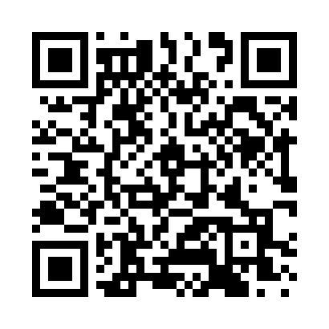
Prayer times for Mooers Forks, New York, USA
Mon 1 Jul 2024 - Wed 31 Jul 2024
High Latitude Method: Angle Based Rule
Prayer Calculation Method: Islamic Society of North America
Asar Calculation Method: Shafi

Date | Day | Fajr | Sunrise | Dhuhr | Asr | Maghrib | Isha
1 | Mon | 3:17 | 5:12 | 12:59 | 5:07 | 8:45 | 10:40
2 | Tue | 3:18 | 5:13 | 12:59 | 5:07 | 8:44 | 10:39
3 | Wed | 3:19 | 5:13 | 12:59 | 5:07 | 8:44 | 10:38
4 | Thu | 3:20 | 5:14 | 12:59 | 5:07 | 8:44 | 10:38
5 | Fri | 3:21 | 5:15 | 12:59 | 5:07 | 8:44 | 10:37
6 | Sat | 3:22 | 5:16 | 12:59 | 5:07 | 8:43 | 10:36
7 | Sun | 3:23 | 5:16 | 1:00 | 5:07 | 8:43 | 10:35
8 | Mon | 3:25 | 5:17 | 1:00 | 5:07 | 8:42 | 10:34
9 | Tue | 3:26 | 5:18 | 1:00 | 5:07 | 8:42 | 10:33
10 | Wed | 3:27 | 5:19 | 1:00 | 5:07 | 8:41 | 10:32
11 | Thu | 3:28 | 5:19 | 1:00 | 5:07 | 8:41 | 10:31
12 | Fri | 3:30 | 5:20 | 1:00 | 5:07 | 8:40 | 10:30
13 | Sat | 3:31 | 5:21 | 1:00 | 5:07 | 8:39 | 10:29
14 | Sun | 3:33 | 5:22 | 1:01 | 5:07 | 8:39 | 10:28
15 | Mon | 3:34 | 5:23 | 1:01 | 5:07 | 8:38 | 10:27
16 | Tue | 3:35 | 5:24 | 1:01 | 5:07 | 8:37 | 10:25
17 | Wed | 3:37 | 5:25 | 1:01 | 5:07 | 8:36 | 10:24
18 | Thu | 3:38 | 5:26 | 1:01 | 5:06 | 8:36 | 10:22
19 | Fri | 3:40 | 5:27 | 1:01 | 5:06 | 8:35 | 10:21
20 | Sat | 3:42 | 5:28 | 1:01 | 5:06 | 8:34 | 10:20
21 | Sun | 3:43 | 5:29 | 1:01 | 5:06 | 8:33 | 10:18
22 | Mon | 3:45 | 5:30 | 1:01 | 5:05 | 8:32 | 10:17
23 | Tue | 3:46 | 5:31 | 1:01 | 5:05 | 8:31 | 10:15
24 | Wed | 3:48 | 5:32 | 1:01 | 5:05 | 8:30 | 10:13
25 | Thu | 3:50 | 5:33 | 1:01 | 5:04 | 8:29 | 10:12
26 | Fri | 3:51 | 5:34 | 1:01 | 5:04 | 8:28 | 10:10
27 | Sat | 3:53 | 5:35 | 1:01 | 5:04 | 8:26 | 10:08
28 | Sun | 3:55 | 5:36 | 1:01 | 5:03 | 8:25 | 10:07
29 | Mon | 3:56 | 5:37 | 1:01 | 5:03 | 8:24 | 10:05
30 | Tue | 3:58 | 5:38 | 1:01 | 5:02 | 8:23 | 10:03
31 | Wed | 4:00 | 5:40 | 1:01 | 5:02 | 8:22 | 10:01
Prayer times provided by https://www.salahtimes.com

