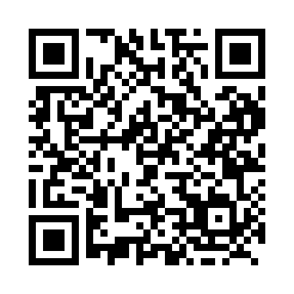
Prayer times for Elsa, Yukon, Canada
Wed 1 May 2024 - Fri 31 May 2024
High Latitude Method: Angle Based Rule
Prayer Calculation Method: Islamic Society of North America
Asar Calculation Method: Hanafi

Date | Day | Fajr | Sunrise | Dhuhr | Asr | Maghrib | Isha
1 | Wed | 3:46 | 5:33 | 1:59 | 7:23 | 10:27 | 12:13
2 | Thu | 3:45 | 5:30 | 1:59 | 7:25 | 10:30 | 12:15
3 | Fri | 3:43 | 5:26 | 1:59 | 7:27 | 10:33 | 12:16
4 | Sat | 3:41 | 5:23 | 1:59 | 7:29 | 10:36 | 12:18
5 | Sun | 3:39 | 5:20 | 1:59 | 7:30 | 10:39 | 12:19
6 | Mon | 3:38 | 5:16 | 1:59 | 7:32 | 10:43 | 12:21
7 | Tue | 3:36 | 5:13 | 1:58 | 7:34 | 10:46 | 12:23
8 | Wed | 3:34 | 5:10 | 1:58 | 7:35 | 10:49 | 12:24
9 | Thu | 3:33 | 5:06 | 1:58 | 7:37 | 10:52 | 12:26
10 | Fri | 3:31 | 5:03 | 1:58 | 7:38 | 10:55 | 12:27
11 | Sat | 3:29 | 5:00 | 1:58 | 7:40 | 10:59 | 12:29
12 | Sun | 3:28 | 4:57 | 1:58 | 7:41 | 11:02 | 12:30
13 | Mon | 3:26 | 4:53 | 1:58 | 7:43 | 11:05 | 12:32
14 | Tue | 3:25 | 4:50 | 1:58 | 7:44 | 11:08 | 12:34
15 | Wed | 3:23 | 4:47 | 1:58 | 7:46 | 11:11 | 12:35
16 | Thu | 3:22 | 4:44 | 1:58 | 7:47 | 11:14 | 12:37
17 | Fri | 3:20 | 4:41 | 1:58 | 7:49 | 11:18 | 12:38
18 | Sat | 3:18 | 4:38 | 1:58 | 7:50 | 11:21 | 12:40
19 | Sun | 3:17 | 4:35 | 1:59 | 7:52 | 11:24 | 12:42
20 | Mon | 3:15 | 4:32 | 1:59 | 7:53 | 11:27 | 12:43
21 | Tue | 3:14 | 4:29 | 1:59 | 7:54 | 11:30 | 12:45
22 | Wed | 3:13 | 4:26 | 1:59 | 7:56 | 11:33 | 12:46
23 | Thu | 3:11 | 4:23 | 1:59 | 7:57 | 11:36 | 12:48
24 | Fri | 3:10 | 4:20 | 1:59 | 7:58 | 11:39 | 12:49
25 | Sat | 3:08 | 4:17 | 1:59 | 7:59 | 11:42 | 12:51
26 | Sun | 3:07 | 4:14 | 1:59 | 8:01 | 11:45 | 12:53
27 | Mon | 3:06 | 4:12 | 1:59 | 8:02 | 11:48 | 12:54
28 | Tue | 3:05 | 4:09 | 1:59 | 8:03 | 11:51 | 12:56
29 | Wed | 3:03 | 4:06 | 2:00 | 8:04 | 11:54 | 12:57
30 | Thu | 3:02 | 4:04 | 2:00 | 8:05 | 11:57 | 12:59
31 | Fri | 3:01 | 4:01 | 2:00 | 8:06 | 11:59 | 1:00
Prayer times provided by https://www.salahtimes.com

