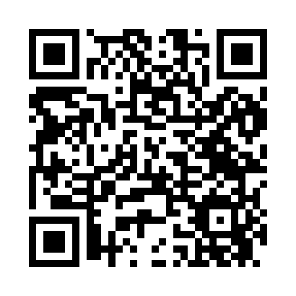
Prayer times for Onycha, Alabama, USA
Mon 1 Jul 2024 - Wed 31 Jul 2024
High Latitude Method: Angle Based Rule
Prayer Calculation Method: Islamic Society of North America
Asar Calculation Method: Shafi

Date | Day | Fajr | Sunrise | Dhuhr | Asr | Maghrib | Isha
1 | Mon | 4:25 | 5:45 | 12:49 | 4:28 | 7:53 | 9:13
2 | Tue | 4:26 | 5:45 | 12:49 | 4:28 | 7:53 | 9:13
3 | Wed | 4:26 | 5:46 | 12:50 | 4:28 | 7:53 | 9:12
4 | Thu | 4:27 | 5:46 | 12:50 | 4:28 | 7:53 | 9:12
5 | Fri | 4:28 | 5:47 | 12:50 | 4:29 | 7:53 | 9:12
6 | Sat | 4:28 | 5:47 | 12:50 | 4:29 | 7:53 | 9:12
7 | Sun | 4:29 | 5:48 | 12:50 | 4:29 | 7:53 | 9:11
8 | Mon | 4:29 | 5:48 | 12:50 | 4:29 | 7:52 | 9:11
9 | Tue | 4:30 | 5:49 | 12:51 | 4:29 | 7:52 | 9:11
10 | Wed | 4:31 | 5:49 | 12:51 | 4:29 | 7:52 | 9:10
11 | Thu | 4:31 | 5:50 | 12:51 | 4:30 | 7:52 | 9:10
12 | Fri | 4:32 | 5:50 | 12:51 | 4:30 | 7:51 | 9:09
13 | Sat | 4:33 | 5:51 | 12:51 | 4:30 | 7:51 | 9:09
14 | Sun | 4:34 | 5:51 | 12:51 | 4:30 | 7:51 | 9:08
15 | Mon | 4:34 | 5:52 | 12:51 | 4:30 | 7:50 | 9:08
16 | Tue | 4:35 | 5:53 | 12:51 | 4:30 | 7:50 | 9:07
17 | Wed | 4:36 | 5:53 | 12:51 | 4:30 | 7:49 | 9:07
18 | Thu | 4:37 | 5:54 | 12:51 | 4:31 | 7:49 | 9:06
19 | Fri | 4:37 | 5:54 | 12:52 | 4:31 | 7:48 | 9:05
20 | Sat | 4:38 | 5:55 | 12:52 | 4:31 | 7:48 | 9:05
21 | Sun | 4:39 | 5:55 | 12:52 | 4:31 | 7:47 | 9:04
22 | Mon | 4:40 | 5:56 | 12:52 | 4:31 | 7:47 | 9:03
23 | Tue | 4:41 | 5:57 | 12:52 | 4:31 | 7:46 | 9:02
24 | Wed | 4:41 | 5:57 | 12:52 | 4:31 | 7:46 | 9:02
25 | Thu | 4:42 | 5:58 | 12:52 | 4:31 | 7:45 | 9:01
26 | Fri | 4:43 | 5:59 | 12:52 | 4:31 | 7:44 | 9:00
27 | Sat | 4:44 | 5:59 | 12:52 | 4:31 | 7:44 | 8:59
28 | Sun | 4:45 | 6:00 | 12:52 | 4:31 | 7:43 | 8:58
29 | Mon | 4:46 | 6:00 | 12:52 | 4:31 | 7:42 | 8:57
30 | Tue | 4:46 | 6:01 | 12:52 | 4:31 | 7:42 | 8:56
31 | Wed | 4:47 | 6:02 | 12:52 | 4:31 | 7:41 | 8:55
Prayer times provided by https://www.salahtimes.com

