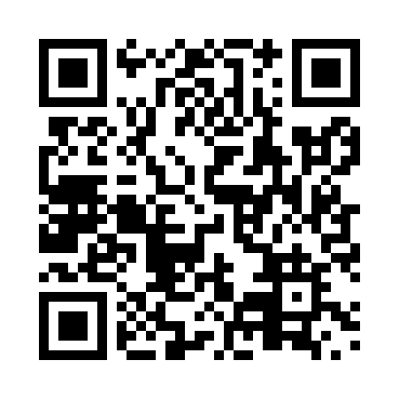
Prayer times for Shulus, British Columbia, Canada
Mon 1 Jul 2024 - Wed 31 Jul 2024
High Latitude Method: Angle Based Rule
Prayer Calculation Method: Islamic Society of North America
Asar Calculation Method: Hanafi

Date | Day | Fajr | Sunrise | Dhuhr | Asr | Maghrib | Isha
1 | Mon | 3:03 | 4:58 | 1:07 | 6:40 | 9:16 | 11:12
2 | Tue | 3:03 | 4:59 | 1:08 | 6:40 | 9:16 | 11:12
3 | Wed | 3:04 | 5:00 | 1:08 | 6:40 | 9:16 | 11:12
4 | Thu | 3:04 | 5:01 | 1:08 | 6:40 | 9:15 | 11:11
5 | Fri | 3:05 | 5:01 | 1:08 | 6:40 | 9:15 | 11:11
6 | Sat | 3:05 | 5:02 | 1:08 | 6:40 | 9:14 | 11:11
7 | Sun | 3:06 | 5:03 | 1:08 | 6:39 | 9:14 | 11:11
8 | Mon | 3:06 | 5:04 | 1:09 | 6:39 | 9:13 | 11:11
9 | Tue | 3:07 | 5:05 | 1:09 | 6:39 | 9:12 | 11:10
10 | Wed | 3:07 | 5:06 | 1:09 | 6:38 | 9:11 | 11:10
11 | Thu | 3:08 | 5:07 | 1:09 | 6:38 | 9:11 | 11:10
12 | Fri | 3:08 | 5:08 | 1:09 | 6:38 | 9:10 | 11:09
13 | Sat | 3:09 | 5:09 | 1:09 | 6:37 | 9:09 | 11:09
14 | Sun | 3:10 | 5:10 | 1:09 | 6:37 | 9:08 | 11:09
15 | Mon | 3:10 | 5:11 | 1:09 | 6:36 | 9:07 | 11:08
16 | Tue | 3:11 | 5:12 | 1:10 | 6:36 | 9:06 | 11:08
17 | Wed | 3:11 | 5:14 | 1:10 | 6:35 | 9:05 | 11:07
18 | Thu | 3:12 | 5:15 | 1:10 | 6:35 | 9:04 | 11:07
19 | Fri | 3:13 | 5:16 | 1:10 | 6:34 | 9:03 | 11:06
20 | Sat | 3:13 | 5:17 | 1:10 | 6:34 | 9:02 | 11:06
21 | Sun | 3:14 | 5:19 | 1:10 | 6:33 | 9:01 | 11:05
22 | Mon | 3:15 | 5:20 | 1:10 | 6:32 | 8:59 | 11:05
23 | Tue | 3:15 | 5:21 | 1:10 | 6:32 | 8:58 | 11:04
24 | Wed | 3:16 | 5:22 | 1:10 | 6:31 | 8:57 | 11:03
25 | Thu | 3:17 | 5:24 | 1:10 | 6:30 | 8:56 | 11:02
26 | Fri | 3:19 | 5:25 | 1:10 | 6:29 | 8:54 | 11:00
27 | Sat | 3:21 | 5:26 | 1:10 | 6:28 | 8:53 | 10:57
28 | Sun | 3:24 | 5:28 | 1:10 | 6:28 | 8:51 | 10:54
29 | Mon | 3:26 | 5:29 | 1:10 | 6:27 | 8:50 | 10:52
30 | Tue | 3:29 | 5:31 | 1:10 | 6:26 | 8:48 | 10:49
31 | Wed | 3:31 | 5:32 | 1:10 | 6:25 | 8:47 | 10:47
Prayer times provided by https://www.salahtimes.com

