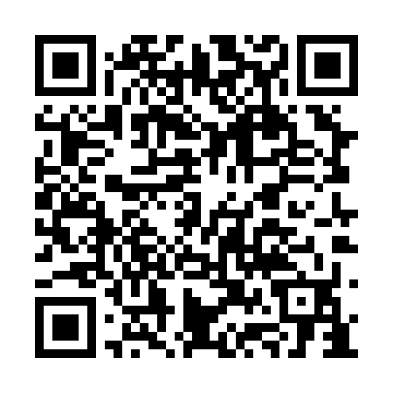
Prayer times for Char Uttarbanda, Bangladesh
Wed 1 May 2024 - Fri 31 May 2024
High Latitude Method: None
Prayer Calculation Method: University of Islamic Sciences
Asar Calculation Method: Shafi

Date | Day | Fajr | Sunrise | Dhuhr | Asr | Maghrib | Isha
1 | Wed | 4:01 | 5:23 | 11:55 | 3:22 | 6:27 | 7:49
2 | Thu | 4:00 | 5:22 | 11:55 | 3:22 | 6:28 | 7:50
3 | Fri | 4:00 | 5:21 | 11:55 | 3:22 | 6:28 | 7:50
4 | Sat | 3:59 | 5:21 | 11:55 | 3:21 | 6:29 | 7:51
5 | Sun | 3:58 | 5:20 | 11:55 | 3:21 | 6:29 | 7:52
6 | Mon | 3:57 | 5:19 | 11:54 | 3:21 | 6:30 | 7:52
7 | Tue | 3:56 | 5:19 | 11:54 | 3:21 | 6:30 | 7:53
8 | Wed | 3:55 | 5:18 | 11:54 | 3:21 | 6:31 | 7:54
9 | Thu | 3:54 | 5:17 | 11:54 | 3:20 | 6:31 | 7:54
10 | Fri | 3:54 | 5:17 | 11:54 | 3:20 | 6:32 | 7:55
11 | Sat | 3:53 | 5:16 | 11:54 | 3:20 | 6:32 | 7:56
12 | Sun | 3:52 | 5:16 | 11:54 | 3:20 | 6:33 | 7:57
13 | Mon | 3:51 | 5:15 | 11:54 | 3:20 | 6:33 | 7:57
14 | Tue | 3:51 | 5:15 | 11:54 | 3:19 | 6:34 | 7:58
15 | Wed | 3:50 | 5:14 | 11:54 | 3:19 | 6:34 | 7:59
16 | Thu | 3:49 | 5:14 | 11:54 | 3:19 | 6:35 | 7:59
17 | Fri | 3:49 | 5:13 | 11:54 | 3:19 | 6:35 | 8:00
18 | Sat | 3:48 | 5:13 | 11:54 | 3:19 | 6:36 | 8:01
19 | Sun | 3:47 | 5:12 | 11:54 | 3:19 | 6:36 | 8:02
20 | Mon | 3:47 | 5:12 | 11:54 | 3:18 | 6:37 | 8:02
21 | Tue | 3:46 | 5:12 | 11:54 | 3:18 | 6:37 | 8:03
22 | Wed | 3:46 | 5:11 | 11:55 | 3:18 | 6:38 | 8:04
23 | Thu | 3:45 | 5:11 | 11:55 | 3:18 | 6:38 | 8:04
24 | Fri | 3:45 | 5:11 | 11:55 | 3:18 | 6:39 | 8:05
25 | Sat | 3:44 | 5:10 | 11:55 | 3:18 | 6:39 | 8:06
26 | Sun | 3:44 | 5:10 | 11:55 | 3:18 | 6:40 | 8:06
27 | Mon | 3:43 | 5:10 | 11:55 | 3:18 | 6:40 | 8:07
28 | Tue | 3:43 | 5:10 | 11:55 | 3:18 | 6:41 | 8:08
29 | Wed | 3:43 | 5:09 | 11:55 | 3:18 | 6:41 | 8:08
30 | Thu | 3:42 | 5:09 | 11:55 | 3:18 | 6:42 | 8:09
31 | Fri | 3:42 | 5:09 | 11:56 | 3:18 | 6:42 | 8:09
Prayer times provided by https://www.salahtimes.com

