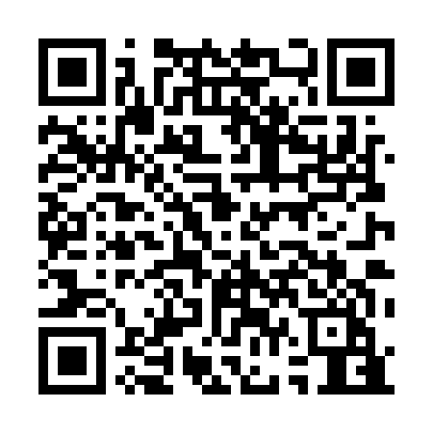
Prayer times for Agamenticus Station, Maine, USA
Mon 1 Apr 2024 - Tue 30 Apr 2024
High Latitude Method: Angle Based Rule
Prayer Calculation Method: Islamic Society of North America
Asar Calculation Method: Shafi

Date | Day | Fajr | Sunrise | Dhuhr | Asr | Maghrib | Isha
1 | Mon | 5:04 | 6:24 | 12:47 | 4:22 | 7:10 | 8:31
2 | Tue | 5:02 | 6:22 | 12:46 | 4:22 | 7:11 | 8:32
3 | Wed | 5:00 | 6:21 | 12:46 | 4:23 | 7:13 | 8:34
4 | Thu | 4:58 | 6:19 | 12:46 | 4:23 | 7:14 | 8:35
5 | Fri | 4:56 | 6:17 | 12:46 | 4:24 | 7:15 | 8:36
6 | Sat | 4:54 | 6:15 | 12:45 | 4:24 | 7:16 | 8:38
7 | Sun | 4:52 | 6:14 | 12:45 | 4:25 | 7:17 | 8:39
8 | Mon | 4:50 | 6:12 | 12:45 | 4:25 | 7:18 | 8:41
9 | Tue | 4:48 | 6:10 | 12:44 | 4:26 | 7:20 | 8:42
10 | Wed | 4:46 | 6:08 | 12:44 | 4:26 | 7:21 | 8:44
11 | Thu | 4:44 | 6:07 | 12:44 | 4:27 | 7:22 | 8:45
12 | Fri | 4:42 | 6:05 | 12:44 | 4:27 | 7:23 | 8:47
13 | Sat | 4:40 | 6:03 | 12:43 | 4:28 | 7:24 | 8:48
14 | Sun | 4:38 | 6:02 | 12:43 | 4:28 | 7:25 | 8:50
15 | Mon | 4:36 | 6:00 | 12:43 | 4:28 | 7:27 | 8:51
16 | Tue | 4:34 | 5:58 | 12:43 | 4:29 | 7:28 | 8:53
17 | Wed | 4:32 | 5:57 | 12:43 | 4:29 | 7:29 | 8:54
18 | Thu | 4:30 | 5:55 | 12:42 | 4:30 | 7:30 | 8:56
19 | Fri | 4:28 | 5:54 | 12:42 | 4:30 | 7:31 | 8:57
20 | Sat | 4:26 | 5:52 | 12:42 | 4:30 | 7:32 | 8:59
21 | Sun | 4:24 | 5:50 | 12:42 | 4:31 | 7:34 | 9:00
22 | Mon | 4:22 | 5:49 | 12:41 | 4:31 | 7:35 | 9:02
23 | Tue | 4:20 | 5:47 | 12:41 | 4:32 | 7:36 | 9:03
24 | Wed | 4:18 | 5:46 | 12:41 | 4:32 | 7:37 | 9:05
25 | Thu | 4:17 | 5:44 | 12:41 | 4:32 | 7:38 | 9:06
26 | Fri | 4:15 | 5:43 | 12:41 | 4:33 | 7:39 | 9:08
27 | Sat | 4:13 | 5:41 | 12:41 | 4:33 | 7:41 | 9:10
28 | Sun | 4:11 | 5:40 | 12:41 | 4:34 | 7:42 | 9:11
29 | Mon | 4:09 | 5:38 | 12:40 | 4:34 | 7:43 | 9:13
30 | Tue | 4:07 | 5:37 | 12:40 | 4:34 | 7:44 | 9:14
Prayer times provided by https://www.salahtimes.com

