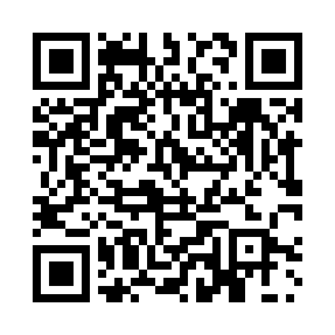
Prayer times for Rechytsa, Belarus
Wed 1 May 2024 - Fri 31 May 2024
High Latitude Method: Angle Based Rule
Prayer Calculation Method: Muslim World League
Asar Calculation Method: Shafi

Date | Day | Fajr | Sunrise | Dhuhr | Asr | Maghrib | Isha
1 | Wed | 2:51 | 5:27 | 12:56 | 4:59 | 8:25 | 10:49
2 | Thu | 2:47 | 5:25 | 12:55 | 5:00 | 8:27 | 10:53
3 | Fri | 2:43 | 5:23 | 12:55 | 5:01 | 8:28 | 10:56
4 | Sat | 2:42 | 5:21 | 12:55 | 5:01 | 8:30 | 11:00
5 | Sun | 2:41 | 5:19 | 12:55 | 5:02 | 8:32 | 11:01
6 | Mon | 2:40 | 5:18 | 12:55 | 5:03 | 8:33 | 11:02
7 | Tue | 2:40 | 5:16 | 12:55 | 5:03 | 8:35 | 11:03
8 | Wed | 2:39 | 5:14 | 12:55 | 5:04 | 8:37 | 11:03
9 | Thu | 2:38 | 5:12 | 12:55 | 5:05 | 8:38 | 11:04
10 | Fri | 2:37 | 5:11 | 12:55 | 5:05 | 8:40 | 11:05
11 | Sat | 2:37 | 5:09 | 12:55 | 5:06 | 8:42 | 11:05
12 | Sun | 2:36 | 5:07 | 12:55 | 5:07 | 8:43 | 11:06
13 | Mon | 2:35 | 5:06 | 12:55 | 5:07 | 8:45 | 11:07
14 | Tue | 2:35 | 5:04 | 12:55 | 5:08 | 8:46 | 11:07
15 | Wed | 2:34 | 5:03 | 12:55 | 5:09 | 8:48 | 11:08
16 | Thu | 2:34 | 5:01 | 12:55 | 5:09 | 8:49 | 11:09
17 | Fri | 2:33 | 5:00 | 12:55 | 5:10 | 8:51 | 11:09
18 | Sat | 2:32 | 4:58 | 12:55 | 5:10 | 8:53 | 11:10
19 | Sun | 2:32 | 4:57 | 12:55 | 5:11 | 8:54 | 11:11
20 | Mon | 2:31 | 4:55 | 12:55 | 5:12 | 8:55 | 11:11
21 | Tue | 2:31 | 4:54 | 12:55 | 5:12 | 8:57 | 11:12
22 | Wed | 2:30 | 4:53 | 12:55 | 5:13 | 8:58 | 11:13
23 | Thu | 2:30 | 4:51 | 12:55 | 5:13 | 9:00 | 11:13
24 | Fri | 2:30 | 4:50 | 12:55 | 5:14 | 9:01 | 11:14
25 | Sat | 2:29 | 4:49 | 12:55 | 5:14 | 9:02 | 11:15
26 | Sun | 2:29 | 4:48 | 12:56 | 5:15 | 9:04 | 11:15
27 | Mon | 2:28 | 4:47 | 12:56 | 5:15 | 9:05 | 11:16
28 | Tue | 2:28 | 4:46 | 12:56 | 5:16 | 9:06 | 11:17
29 | Wed | 2:28 | 4:45 | 12:56 | 5:16 | 9:08 | 11:17
30 | Thu | 2:27 | 4:44 | 12:56 | 5:17 | 9:09 | 11:18
31 | Fri | 2:27 | 4:43 | 12:56 | 5:17 | 9:10 | 11:18
Prayer times provided by https://www.salahtimes.com

