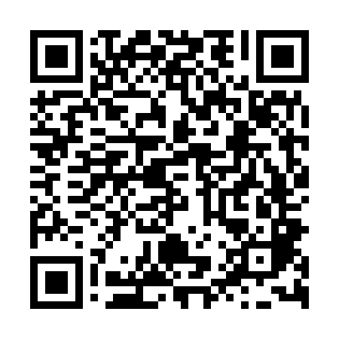
Prayer times for Ulleung County, South Korea
Mon 1 Apr 2024 - Tue 30 Apr 2024
High Latitude Method: None
Prayer Calculation Method: Muslim World League
Asar Calculation Method: Shafi

Date | Day | Fajr | Sunrise | Dhuhr | Asr | Maghrib | Isha
1 | Mon | 4:33 | 6:02 | 12:20 | 3:54 | 6:39 | 8:03
2 | Tue | 4:31 | 6:00 | 12:20 | 3:55 | 6:40 | 8:04
3 | Wed | 4:29 | 5:59 | 12:20 | 3:55 | 6:41 | 8:05
4 | Thu | 4:28 | 5:57 | 12:19 | 3:55 | 6:42 | 8:06
5 | Fri | 4:26 | 5:56 | 12:19 | 3:56 | 6:43 | 8:07
6 | Sat | 4:24 | 5:55 | 12:19 | 3:56 | 6:44 | 8:09
7 | Sun | 4:23 | 5:53 | 12:18 | 3:56 | 6:45 | 8:10
8 | Mon | 4:21 | 5:52 | 12:18 | 3:56 | 6:45 | 8:11
9 | Tue | 4:19 | 5:50 | 12:18 | 3:57 | 6:46 | 8:12
10 | Wed | 4:18 | 5:49 | 12:18 | 3:57 | 6:47 | 8:13
11 | Thu | 4:16 | 5:47 | 12:17 | 3:57 | 6:48 | 8:14
12 | Fri | 4:14 | 5:46 | 12:17 | 3:57 | 6:49 | 8:15
13 | Sat | 4:12 | 5:44 | 12:17 | 3:57 | 6:50 | 8:17
14 | Sun | 4:11 | 5:43 | 12:17 | 3:58 | 6:51 | 8:18
15 | Mon | 4:09 | 5:42 | 12:16 | 3:58 | 6:52 | 8:19
16 | Tue | 4:07 | 5:40 | 12:16 | 3:58 | 6:53 | 8:20
17 | Wed | 4:06 | 5:39 | 12:16 | 3:58 | 6:54 | 8:21
18 | Thu | 4:04 | 5:38 | 12:16 | 3:58 | 6:54 | 8:22
19 | Fri | 4:02 | 5:36 | 12:16 | 3:59 | 6:55 | 8:24
20 | Sat | 4:01 | 5:35 | 12:15 | 3:59 | 6:56 | 8:25
21 | Sun | 3:59 | 5:34 | 12:15 | 3:59 | 6:57 | 8:26
22 | Mon | 3:57 | 5:32 | 12:15 | 3:59 | 6:58 | 8:27
23 | Tue | 3:56 | 5:31 | 12:15 | 3:59 | 6:59 | 8:28
24 | Wed | 3:54 | 5:30 | 12:15 | 4:00 | 7:00 | 8:30
25 | Thu | 3:53 | 5:28 | 12:14 | 4:00 | 7:01 | 8:31
26 | Fri | 3:51 | 5:27 | 12:14 | 4:00 | 7:02 | 8:32
27 | Sat | 3:49 | 5:26 | 12:14 | 4:00 | 7:03 | 8:33
28 | Sun | 3:48 | 5:25 | 12:14 | 4:00 | 7:04 | 8:35
29 | Mon | 3:46 | 5:24 | 12:14 | 4:00 | 7:04 | 8:36
30 | Tue | 3:45 | 5:22 | 12:14 | 4:01 | 7:05 | 8:37
Prayer times provided by https://www.salahtimes.com

