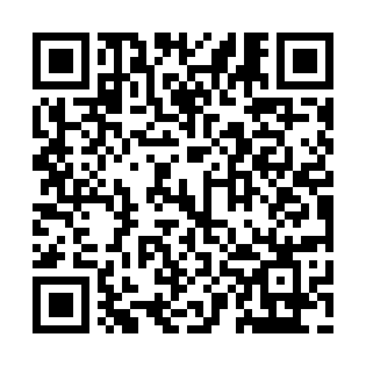
Prayer times for Clearsand Beach, Saskatchewan, Canada
Wed 1 May 2024 - Fri 31 May 2024
High Latitude Method: Angle Based Rule
Prayer Calculation Method: Islamic Society of North America
Asar Calculation Method: Hanafi

Date | Day | Fajr | Sunrise | Dhuhr | Asr | Maghrib | Isha
1 | Wed | 3:19 | 5:27 | 1:00 | 6:10 | 8:35 | 10:44
2 | Thu | 3:16 | 5:25 | 1:00 | 6:11 | 8:37 | 10:47
3 | Fri | 3:12 | 5:23 | 1:00 | 6:13 | 8:38 | 10:50
4 | Sat | 3:11 | 5:21 | 1:00 | 6:14 | 8:40 | 10:50
5 | Sun | 3:10 | 5:19 | 1:00 | 6:15 | 8:42 | 10:51
6 | Mon | 3:09 | 5:17 | 1:00 | 6:16 | 8:44 | 10:52
7 | Tue | 3:08 | 5:15 | 1:00 | 6:17 | 8:45 | 10:53
8 | Wed | 3:07 | 5:13 | 1:00 | 6:18 | 8:47 | 10:54
9 | Thu | 3:06 | 5:12 | 1:00 | 6:19 | 8:49 | 10:55
10 | Fri | 3:05 | 5:10 | 1:00 | 6:20 | 8:51 | 10:55
11 | Sat | 3:04 | 5:08 | 1:00 | 6:21 | 8:52 | 10:56
12 | Sun | 3:03 | 5:06 | 1:00 | 6:22 | 8:54 | 10:57
13 | Mon | 3:02 | 5:05 | 1:00 | 6:23 | 8:56 | 10:58
14 | Tue | 3:02 | 5:03 | 1:00 | 6:24 | 8:57 | 10:59
15 | Wed | 3:01 | 5:01 | 1:00 | 6:25 | 8:59 | 11:00
16 | Thu | 3:00 | 5:00 | 1:00 | 6:26 | 9:01 | 11:00
17 | Fri | 2:59 | 4:58 | 1:00 | 6:27 | 9:02 | 11:01
18 | Sat | 2:58 | 4:57 | 1:00 | 6:28 | 9:04 | 11:02
19 | Sun | 2:58 | 4:55 | 1:00 | 6:29 | 9:05 | 11:03
20 | Mon | 2:57 | 4:54 | 1:00 | 6:29 | 9:07 | 11:04
21 | Tue | 2:56 | 4:52 | 1:00 | 6:30 | 9:08 | 11:04
22 | Wed | 2:56 | 4:51 | 1:00 | 6:31 | 9:10 | 11:05
23 | Thu | 2:55 | 4:50 | 1:00 | 6:32 | 9:11 | 11:06
24 | Fri | 2:55 | 4:48 | 1:00 | 6:33 | 9:13 | 11:07
25 | Sat | 2:54 | 4:47 | 1:00 | 6:34 | 9:14 | 11:08
26 | Sun | 2:53 | 4:46 | 1:01 | 6:34 | 9:16 | 11:08
27 | Mon | 2:53 | 4:45 | 1:01 | 6:35 | 9:17 | 11:09
28 | Tue | 2:52 | 4:44 | 1:01 | 6:36 | 9:18 | 11:10
29 | Wed | 2:52 | 4:43 | 1:01 | 6:37 | 9:20 | 11:10
30 | Thu | 2:52 | 4:42 | 1:01 | 6:38 | 9:21 | 11:11
31 | Fri | 2:51 | 4:41 | 1:01 | 6:38 | 9:22 | 11:12
Prayer times provided by https://www.salahtimes.com

