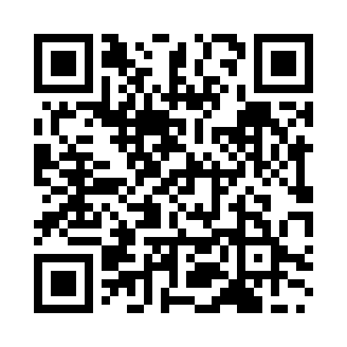
Prayer times for Nonoichi, Japan
Mon 1 Apr 2024 - Tue 30 Apr 2024
High Latitude Method: None
Prayer Calculation Method: Muslim World League
Asar Calculation Method: Shafi

Date | Day | Fajr | Sunrise | Dhuhr | Asr | Maghrib | Isha
1 | Mon | 4:12 | 5:40 | 11:57 | 3:31 | 6:16 | 7:38
2 | Tue | 4:10 | 5:38 | 11:57 | 3:32 | 6:17 | 7:39
3 | Wed | 4:08 | 5:37 | 11:57 | 3:32 | 6:17 | 7:41
4 | Thu | 4:07 | 5:35 | 11:56 | 3:32 | 6:18 | 7:42
5 | Fri | 4:05 | 5:34 | 11:56 | 3:32 | 6:19 | 7:43
6 | Sat | 4:04 | 5:32 | 11:56 | 3:33 | 6:20 | 7:44
7 | Sun | 4:02 | 5:31 | 11:56 | 3:33 | 6:21 | 7:45
8 | Mon | 4:00 | 5:30 | 11:55 | 3:33 | 6:22 | 7:46
9 | Tue | 3:59 | 5:28 | 11:55 | 3:33 | 6:23 | 7:47
10 | Wed | 3:57 | 5:27 | 11:55 | 3:33 | 6:23 | 7:48
11 | Thu | 3:55 | 5:25 | 11:55 | 3:34 | 6:24 | 7:49
12 | Fri | 3:54 | 5:24 | 11:54 | 3:34 | 6:25 | 7:50
13 | Sat | 3:52 | 5:23 | 11:54 | 3:34 | 6:26 | 7:51
14 | Sun | 3:50 | 5:21 | 11:54 | 3:34 | 6:27 | 7:52
15 | Mon | 3:49 | 5:20 | 11:54 | 3:34 | 6:28 | 7:53
16 | Tue | 3:47 | 5:19 | 11:53 | 3:34 | 6:29 | 7:55
17 | Wed | 3:46 | 5:17 | 11:53 | 3:35 | 6:29 | 7:56
18 | Thu | 3:44 | 5:16 | 11:53 | 3:35 | 6:30 | 7:57
19 | Fri | 3:42 | 5:15 | 11:53 | 3:35 | 6:31 | 7:58
20 | Sat | 3:41 | 5:13 | 11:52 | 3:35 | 6:32 | 7:59
21 | Sun | 3:39 | 5:12 | 11:52 | 3:35 | 6:33 | 8:00
22 | Mon | 3:38 | 5:11 | 11:52 | 3:35 | 6:34 | 8:01
23 | Tue | 3:36 | 5:10 | 11:52 | 3:36 | 6:35 | 8:03
24 | Wed | 3:34 | 5:08 | 11:52 | 3:36 | 6:36 | 8:04
25 | Thu | 3:33 | 5:07 | 11:51 | 3:36 | 6:36 | 8:05
26 | Fri | 3:31 | 5:06 | 11:51 | 3:36 | 6:37 | 8:06
27 | Sat | 3:30 | 5:05 | 11:51 | 3:36 | 6:38 | 8:07
28 | Sun | 3:28 | 5:04 | 11:51 | 3:36 | 6:39 | 8:09
29 | Mon | 3:27 | 5:02 | 11:51 | 3:36 | 6:40 | 8:10
30 | Tue | 3:25 | 5:01 | 11:51 | 3:37 | 6:41 | 8:11
Prayer times provided by https://www.salahtimes.com

