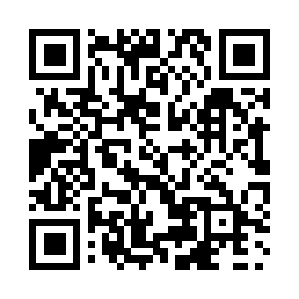
Prayer times for Village Bay, British Columbia, Canada
Mon 1 Apr 2024 - Tue 30 Apr 2024
High Latitude Method: Angle Based Rule
Prayer Calculation Method: Islamic Society of North America
Asar Calculation Method: Hanafi

Date | Day | Fajr | Sunrise | Dhuhr | Asr | Maghrib | Isha
1 | Mon | 5:19 | 6:49 | 1:17 | 5:46 | 7:45 | 9:16
2 | Tue | 5:17 | 6:47 | 1:17 | 5:47 | 7:47 | 9:18
3 | Wed | 5:14 | 6:45 | 1:16 | 5:48 | 7:48 | 9:19
4 | Thu | 5:12 | 6:43 | 1:16 | 5:49 | 7:50 | 9:21
5 | Fri | 5:09 | 6:41 | 1:16 | 5:50 | 7:51 | 9:23
6 | Sat | 5:07 | 6:39 | 1:15 | 5:51 | 7:53 | 9:25
7 | Sun | 5:05 | 6:37 | 1:15 | 5:52 | 7:54 | 9:27
8 | Mon | 5:02 | 6:35 | 1:15 | 5:53 | 7:56 | 9:29
9 | Tue | 5:00 | 6:33 | 1:15 | 5:54 | 7:57 | 9:31
10 | Wed | 4:57 | 6:31 | 1:14 | 5:55 | 7:59 | 9:33
11 | Thu | 4:55 | 6:29 | 1:14 | 5:56 | 8:00 | 9:35
12 | Fri | 4:52 | 6:27 | 1:14 | 5:57 | 8:02 | 9:37
13 | Sat | 4:50 | 6:25 | 1:14 | 5:58 | 8:03 | 9:38
14 | Sun | 4:47 | 6:23 | 1:13 | 5:59 | 8:05 | 9:40
15 | Mon | 4:45 | 6:21 | 1:13 | 6:00 | 8:06 | 9:42
16 | Tue | 4:43 | 6:19 | 1:13 | 6:01 | 8:08 | 9:44
17 | Wed | 4:40 | 6:17 | 1:13 | 6:02 | 8:09 | 9:46
18 | Thu | 4:38 | 6:15 | 1:12 | 6:03 | 8:11 | 9:49
19 | Fri | 4:35 | 6:13 | 1:12 | 6:04 | 8:12 | 9:51
20 | Sat | 4:33 | 6:11 | 1:12 | 6:05 | 8:14 | 9:53
21 | Sun | 4:30 | 6:09 | 1:12 | 6:06 | 8:15 | 9:55
22 | Mon | 4:28 | 6:08 | 1:12 | 6:07 | 8:17 | 9:57
23 | Tue | 4:25 | 6:06 | 1:11 | 6:08 | 8:18 | 9:59
24 | Wed | 4:23 | 6:04 | 1:11 | 6:09 | 8:19 | 10:01
25 | Thu | 4:20 | 6:02 | 1:11 | 6:10 | 8:21 | 10:03
26 | Fri | 4:18 | 6:00 | 1:11 | 6:10 | 8:22 | 10:05
27 | Sat | 4:15 | 5:58 | 1:11 | 6:11 | 8:24 | 10:07
28 | Sun | 4:13 | 5:57 | 1:11 | 6:12 | 8:25 | 10:10
29 | Mon | 4:10 | 5:55 | 1:11 | 6:13 | 8:27 | 10:12
30 | Tue | 4:08 | 5:53 | 1:10 | 6:14 | 8:28 | 10:14
Prayer times provided by https://www.salahtimes.com

