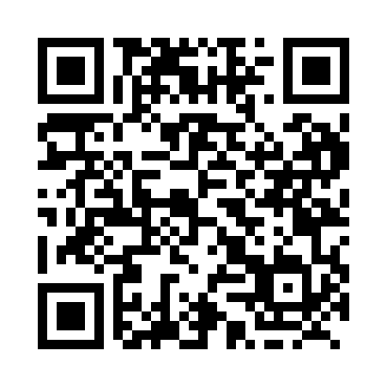
Prayer times for Terrace Bay, Ontario, Canada
Mon 1 Jul 2024 - Wed 31 Jul 2024
High Latitude Method: Angle Based Rule
Prayer Calculation Method: Islamic Society of North America
Asar Calculation Method: Hanafi

Date | Day | Fajr | Sunrise | Dhuhr | Asr | Maghrib | Isha
1 | Mon | 3:51 | 5:50 | 1:52 | 7:22 | 9:55 | 11:54
2 | Tue | 3:51 | 5:50 | 1:53 | 7:22 | 9:55 | 11:54
3 | Wed | 3:52 | 5:51 | 1:53 | 7:22 | 9:54 | 11:53
4 | Thu | 3:52 | 5:52 | 1:53 | 7:22 | 9:54 | 11:53
5 | Fri | 3:53 | 5:53 | 1:53 | 7:22 | 9:53 | 11:53
6 | Sat | 3:53 | 5:54 | 1:53 | 7:22 | 9:53 | 11:53
7 | Sun | 3:54 | 5:54 | 1:53 | 7:22 | 9:52 | 11:53
8 | Mon | 3:54 | 5:55 | 1:54 | 7:21 | 9:52 | 11:53
9 | Tue | 3:55 | 5:56 | 1:54 | 7:21 | 9:51 | 11:52
10 | Wed | 3:55 | 5:57 | 1:54 | 7:21 | 9:50 | 11:52
11 | Thu | 3:56 | 5:58 | 1:54 | 7:20 | 9:50 | 11:52
12 | Fri | 3:56 | 5:59 | 1:54 | 7:20 | 9:49 | 11:51
13 | Sat | 3:57 | 6:00 | 1:54 | 7:20 | 9:48 | 11:51
14 | Sun | 3:58 | 6:01 | 1:54 | 7:19 | 9:47 | 11:51
15 | Mon | 3:58 | 6:02 | 1:54 | 7:19 | 9:46 | 11:50
16 | Tue | 3:59 | 6:03 | 1:55 | 7:18 | 9:45 | 11:50
17 | Wed | 3:59 | 6:04 | 1:55 | 7:18 | 9:45 | 11:49
18 | Thu | 4:00 | 6:05 | 1:55 | 7:17 | 9:44 | 11:49
19 | Fri | 4:01 | 6:07 | 1:55 | 7:17 | 9:42 | 11:47
20 | Sat | 4:03 | 6:08 | 1:55 | 7:16 | 9:41 | 11:45
21 | Sun | 4:06 | 6:09 | 1:55 | 7:16 | 9:40 | 11:43
22 | Mon | 4:08 | 6:10 | 1:55 | 7:15 | 9:39 | 11:41
23 | Tue | 4:10 | 6:11 | 1:55 | 7:14 | 9:38 | 11:39
24 | Wed | 4:12 | 6:13 | 1:55 | 7:14 | 9:37 | 11:37
25 | Thu | 4:14 | 6:14 | 1:55 | 7:13 | 9:35 | 11:34
26 | Fri | 4:17 | 6:15 | 1:55 | 7:12 | 9:34 | 11:32
27 | Sat | 4:19 | 6:16 | 1:55 | 7:11 | 9:33 | 11:30
28 | Sun | 4:21 | 6:18 | 1:55 | 7:11 | 9:32 | 11:28
29 | Mon | 4:23 | 6:19 | 1:55 | 7:10 | 9:30 | 11:25
30 | Tue | 4:25 | 6:20 | 1:55 | 7:09 | 9:29 | 11:23
31 | Wed | 4:28 | 6:22 | 1:55 | 7:08 | 9:27 | 11:21
Prayer times provided by https://www.salahtimes.com

