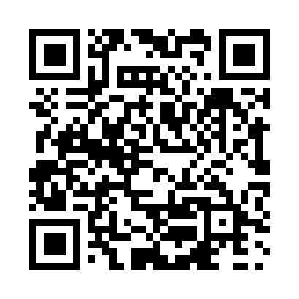
Prayer times for Uranium City, Saskatchewan, Canada
Wed 1 May 2024 - Fri 31 May 2024
High Latitude Method: Angle Based Rule
Prayer Calculation Method: Islamic Society of North America
Asar Calculation Method: Hanafi

Date | Day | Fajr | Sunrise | Dhuhr | Asr | Maghrib | Isha
1 | Wed | 3:12 | 5:12 | 1:11 | 6:29 | 9:12 | 11:12
2 | Thu | 3:11 | 5:10 | 1:11 | 6:30 | 9:14 | 11:13
3 | Fri | 3:10 | 5:07 | 1:11 | 6:32 | 9:17 | 11:14
4 | Sat | 3:08 | 5:05 | 1:11 | 6:33 | 9:19 | 11:15
5 | Sun | 3:07 | 5:02 | 1:11 | 6:35 | 9:21 | 11:17
6 | Mon | 3:06 | 5:00 | 1:11 | 6:36 | 9:24 | 11:18
7 | Tue | 3:04 | 4:57 | 1:11 | 6:37 | 9:26 | 11:19
8 | Wed | 3:03 | 4:55 | 1:11 | 6:39 | 9:29 | 11:20
9 | Thu | 3:02 | 4:52 | 1:11 | 6:40 | 9:31 | 11:21
10 | Fri | 3:01 | 4:50 | 1:11 | 6:41 | 9:33 | 11:22
11 | Sat | 2:59 | 4:47 | 1:11 | 6:43 | 9:36 | 11:24
12 | Sun | 2:58 | 4:45 | 1:11 | 6:44 | 9:38 | 11:25
13 | Mon | 2:57 | 4:43 | 1:11 | 6:45 | 9:40 | 11:26
14 | Tue | 2:56 | 4:40 | 1:11 | 6:46 | 9:43 | 11:27
15 | Wed | 2:55 | 4:38 | 1:11 | 6:48 | 9:45 | 11:28
16 | Thu | 2:54 | 4:36 | 1:11 | 6:49 | 9:47 | 11:29
17 | Fri | 2:53 | 4:34 | 1:11 | 6:50 | 9:49 | 11:30
18 | Sat | 2:51 | 4:31 | 1:11 | 6:51 | 9:51 | 11:31
19 | Sun | 2:50 | 4:29 | 1:11 | 6:52 | 9:54 | 11:33
20 | Mon | 2:49 | 4:27 | 1:11 | 6:54 | 9:56 | 11:34
21 | Tue | 2:48 | 4:25 | 1:11 | 6:55 | 9:58 | 11:35
22 | Wed | 2:48 | 4:23 | 1:11 | 6:56 | 10:00 | 11:36
23 | Thu | 2:47 | 4:21 | 1:11 | 6:57 | 10:02 | 11:37
24 | Fri | 2:46 | 4:20 | 1:11 | 6:58 | 10:04 | 11:38
25 | Sat | 2:45 | 4:18 | 1:11 | 6:59 | 10:06 | 11:39
26 | Sun | 2:44 | 4:16 | 1:12 | 7:00 | 10:08 | 11:40
27 | Mon | 2:43 | 4:14 | 1:12 | 7:01 | 10:10 | 11:41
28 | Tue | 2:42 | 4:13 | 1:12 | 7:02 | 10:12 | 11:42
29 | Wed | 2:42 | 4:11 | 1:12 | 7:03 | 10:14 | 11:43
30 | Thu | 2:41 | 4:10 | 1:12 | 7:04 | 10:15 | 11:44
31 | Fri | 2:40 | 4:08 | 1:12 | 7:05 | 10:17 | 11:45
Prayer times provided by https://www.salahtimes.com

