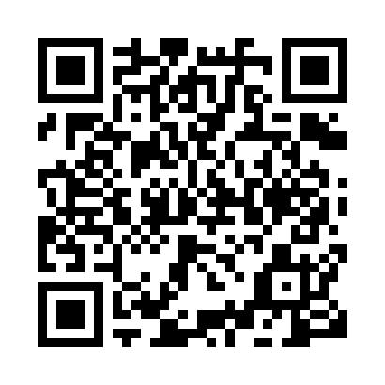
Prayer times for Bekoko, Cameroon
Mon 1 Apr 2024 - Tue 30 Apr 2024
High Latitude Method: None
Prayer Calculation Method: Muslim World League
Asar Calculation Method: Shafi

Date | Day | Fajr | Sunrise | Dhuhr | Asr | Maghrib | Isha
1 | Mon | 5:06 | 6:15 | 12:19 | 3:24 | 6:23 | 7:28
2 | Tue | 5:05 | 6:14 | 12:18 | 3:24 | 6:22 | 7:28
3 | Wed | 5:05 | 6:14 | 12:18 | 3:25 | 6:22 | 7:27
4 | Thu | 5:04 | 6:14 | 12:18 | 3:25 | 6:22 | 7:27
5 | Fri | 5:04 | 6:13 | 12:18 | 3:25 | 6:22 | 7:27
6 | Sat | 5:04 | 6:13 | 12:17 | 3:26 | 6:22 | 7:27
7 | Sun | 5:03 | 6:13 | 12:17 | 3:26 | 6:21 | 7:27
8 | Mon | 5:03 | 6:12 | 12:17 | 3:26 | 6:21 | 7:26
9 | Tue | 5:02 | 6:12 | 12:16 | 3:27 | 6:21 | 7:26
10 | Wed | 5:02 | 6:12 | 12:16 | 3:27 | 6:21 | 7:26
11 | Thu | 5:02 | 6:11 | 12:16 | 3:27 | 6:21 | 7:26
12 | Fri | 5:01 | 6:11 | 12:16 | 3:28 | 6:20 | 7:26
13 | Sat | 5:01 | 6:11 | 12:15 | 3:28 | 6:20 | 7:26
14 | Sun | 5:01 | 6:10 | 12:15 | 3:28 | 6:20 | 7:26
15 | Mon | 5:00 | 6:10 | 12:15 | 3:28 | 6:20 | 7:26
16 | Tue | 5:00 | 6:10 | 12:15 | 3:29 | 6:20 | 7:26
17 | Wed | 4:59 | 6:09 | 12:14 | 3:29 | 6:19 | 7:25
18 | Thu | 4:59 | 6:09 | 12:14 | 3:29 | 6:19 | 7:25
19 | Fri | 4:59 | 6:09 | 12:14 | 3:29 | 6:19 | 7:25
20 | Sat | 4:58 | 6:09 | 12:14 | 3:30 | 6:19 | 7:25
21 | Sun | 4:58 | 6:08 | 12:14 | 3:30 | 6:19 | 7:25
22 | Mon | 4:58 | 6:08 | 12:13 | 3:30 | 6:19 | 7:25
23 | Tue | 4:57 | 6:08 | 12:13 | 3:30 | 6:19 | 7:25
24 | Wed | 4:57 | 6:08 | 12:13 | 3:30 | 6:18 | 7:25
25 | Thu | 4:57 | 6:07 | 12:13 | 3:31 | 6:18 | 7:25
26 | Fri | 4:56 | 6:07 | 12:13 | 3:31 | 6:18 | 7:25
27 | Sat | 4:56 | 6:07 | 12:13 | 3:31 | 6:18 | 7:25
28 | Sun | 4:56 | 6:07 | 12:12 | 3:31 | 6:18 | 7:25
29 | Mon | 4:55 | 6:07 | 12:12 | 3:32 | 6:18 | 7:25
30 | Tue | 4:55 | 6:06 | 12:12 | 3:32 | 6:18 | 7:25
Prayer times provided by https://www.salahtimes.com

