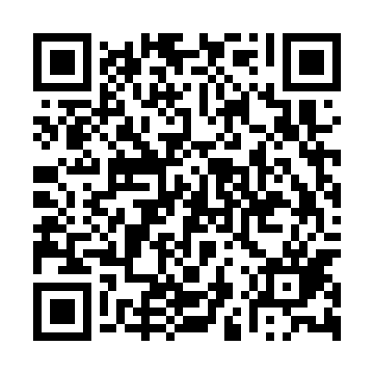
Prayer times for Lamma Island, Hong Kong
Wed 1 May 2024 - Fri 31 May 2024
High Latitude Method: None
Prayer Calculation Method: Muslim World League
Asar Calculation Method: Shafi

Date | Day | Fajr | Sunrise | Dhuhr | Asr | Maghrib | Isha
1 | Wed | 4:32 | 5:51 | 12:21 | 3:43 | 6:50 | 8:05
2 | Thu | 4:31 | 5:51 | 12:20 | 3:43 | 6:50 | 8:05
3 | Fri | 4:30 | 5:50 | 12:20 | 3:43 | 6:51 | 8:06
4 | Sat | 4:30 | 5:50 | 12:20 | 3:42 | 6:51 | 8:06
5 | Sun | 4:29 | 5:49 | 12:20 | 3:42 | 6:52 | 8:07
6 | Mon | 4:28 | 5:48 | 12:20 | 3:42 | 6:52 | 8:08
7 | Tue | 4:27 | 5:48 | 12:20 | 3:41 | 6:52 | 8:08
8 | Wed | 4:27 | 5:47 | 12:20 | 3:41 | 6:53 | 8:09
9 | Thu | 4:26 | 5:47 | 12:20 | 3:41 | 6:53 | 8:10
10 | Fri | 4:25 | 5:46 | 12:20 | 3:41 | 6:54 | 8:10
11 | Sat | 4:24 | 5:46 | 12:20 | 3:40 | 6:54 | 8:11
12 | Sun | 4:24 | 5:45 | 12:20 | 3:40 | 6:55 | 8:11
13 | Mon | 4:23 | 5:45 | 12:20 | 3:40 | 6:55 | 8:12
14 | Tue | 4:22 | 5:44 | 12:20 | 3:39 | 6:56 | 8:13
15 | Wed | 4:22 | 5:44 | 12:20 | 3:39 | 6:56 | 8:13
16 | Thu | 4:21 | 5:43 | 12:20 | 3:39 | 6:57 | 8:14
17 | Fri | 4:21 | 5:43 | 12:20 | 3:39 | 6:57 | 8:14
18 | Sat | 4:20 | 5:43 | 12:20 | 3:39 | 6:57 | 8:15
19 | Sun | 4:20 | 5:42 | 12:20 | 3:38 | 6:58 | 8:16
20 | Mon | 4:19 | 5:42 | 12:20 | 3:38 | 6:58 | 8:16
21 | Tue | 4:18 | 5:42 | 12:20 | 3:38 | 6:59 | 8:17
22 | Wed | 4:18 | 5:41 | 12:20 | 3:38 | 6:59 | 8:18
23 | Thu | 4:18 | 5:41 | 12:20 | 3:38 | 7:00 | 8:18
24 | Fri | 4:17 | 5:41 | 12:20 | 3:37 | 7:00 | 8:19
25 | Sat | 4:17 | 5:40 | 12:20 | 3:37 | 7:01 | 8:19
26 | Sun | 4:16 | 5:40 | 12:21 | 3:37 | 7:01 | 8:20
27 | Mon | 4:16 | 5:40 | 12:21 | 3:37 | 7:01 | 8:20
28 | Tue | 4:16 | 5:40 | 12:21 | 3:37 | 7:02 | 8:21
29 | Wed | 4:15 | 5:40 | 12:21 | 3:37 | 7:02 | 8:22
30 | Thu | 4:15 | 5:40 | 12:21 | 3:37 | 7:03 | 8:22
31 | Fri | 4:15 | 5:39 | 12:21 | 3:37 | 7:03 | 8:23
Prayer times provided by https://www.salahtimes.com

