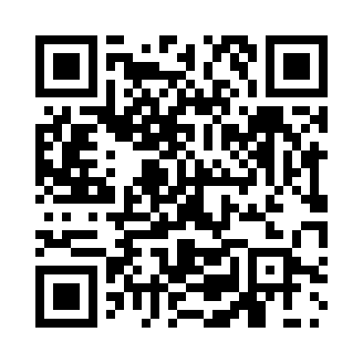
Prayer times for Slonim, Belarus
Wed 1 May 2024 - Fri 31 May 2024
High Latitude Method: Angle Based Rule
Prayer Calculation Method: Muslim World League
Asar Calculation Method: Shafi

Date | Day | Fajr | Sunrise | Dhuhr | Asr | Maghrib | Isha
1 | Wed | 3:04 | 5:45 | 1:16 | 5:20 | 8:48 | 11:18
2 | Thu | 3:03 | 5:43 | 1:16 | 5:21 | 8:50 | 11:21
3 | Fri | 3:02 | 5:41 | 1:16 | 5:22 | 8:51 | 11:21
4 | Sat | 3:01 | 5:39 | 1:15 | 5:22 | 8:53 | 11:22
5 | Sun | 3:00 | 5:37 | 1:15 | 5:23 | 8:55 | 11:23
6 | Mon | 3:00 | 5:35 | 1:15 | 5:24 | 8:56 | 11:23
7 | Tue | 2:59 | 5:33 | 1:15 | 5:25 | 8:58 | 11:24
8 | Wed | 2:58 | 5:31 | 1:15 | 5:25 | 9:00 | 11:25
9 | Thu | 2:57 | 5:30 | 1:15 | 5:26 | 9:02 | 11:26
10 | Fri | 2:56 | 5:28 | 1:15 | 5:27 | 9:03 | 11:26
11 | Sat | 2:56 | 5:26 | 1:15 | 5:27 | 9:05 | 11:27
12 | Sun | 2:55 | 5:24 | 1:15 | 5:28 | 9:07 | 11:28
13 | Mon | 2:54 | 5:23 | 1:15 | 5:29 | 9:08 | 11:28
14 | Tue | 2:54 | 5:21 | 1:15 | 5:29 | 9:10 | 11:29
15 | Wed | 2:53 | 5:20 | 1:15 | 5:30 | 9:11 | 11:30
16 | Thu | 2:52 | 5:18 | 1:15 | 5:31 | 9:13 | 11:30
17 | Fri | 2:52 | 5:16 | 1:15 | 5:31 | 9:15 | 11:31
18 | Sat | 2:51 | 5:15 | 1:15 | 5:32 | 9:16 | 11:32
19 | Sun | 2:51 | 5:13 | 1:15 | 5:32 | 9:18 | 11:33
20 | Mon | 2:50 | 5:12 | 1:15 | 5:33 | 9:19 | 11:33
21 | Tue | 2:50 | 5:11 | 1:15 | 5:34 | 9:21 | 11:34
22 | Wed | 2:49 | 5:09 | 1:15 | 5:34 | 9:22 | 11:35
23 | Thu | 2:49 | 5:08 | 1:16 | 5:35 | 9:24 | 11:35
24 | Fri | 2:48 | 5:07 | 1:16 | 5:35 | 9:25 | 11:36
25 | Sat | 2:48 | 5:06 | 1:16 | 5:36 | 9:27 | 11:37
26 | Sun | 2:47 | 5:04 | 1:16 | 5:36 | 9:28 | 11:37
27 | Mon | 2:47 | 5:03 | 1:16 | 5:37 | 9:29 | 11:38
28 | Tue | 2:47 | 5:02 | 1:16 | 5:38 | 9:30 | 11:38
29 | Wed | 2:46 | 5:01 | 1:16 | 5:38 | 9:32 | 11:39
30 | Thu | 2:46 | 5:00 | 1:16 | 5:39 | 9:33 | 11:40
31 | Fri | 2:46 | 4:59 | 1:17 | 5:39 | 9:34 | 11:40
Prayer times provided by https://www.salahtimes.com

