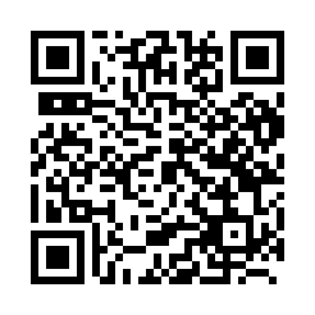
Prayer times for Bovigny, Belgium
Mon 1 Apr 2024 - Tue 30 Apr 2024
High Latitude Method: Angle Based Rule
Prayer Calculation Method: Muslim World League
Asar Calculation Method: Shafi

Date | Day | Fajr | Sunrise | Dhuhr | Asr | Maghrib | Isha
1 | Mon | 5:17 | 7:12 | 1:40 | 5:14 | 8:09 | 9:57
2 | Tue | 5:15 | 7:10 | 1:40 | 5:15 | 8:11 | 9:59
3 | Wed | 5:12 | 7:08 | 1:39 | 5:15 | 8:12 | 10:01
4 | Thu | 5:09 | 7:06 | 1:39 | 5:16 | 8:14 | 10:03
5 | Fri | 5:06 | 7:03 | 1:39 | 5:17 | 8:15 | 10:05
6 | Sat | 5:04 | 7:01 | 1:39 | 5:18 | 8:17 | 10:07
7 | Sun | 5:01 | 6:59 | 1:38 | 5:19 | 8:19 | 10:09
8 | Mon | 4:58 | 6:57 | 1:38 | 5:19 | 8:20 | 10:12
9 | Tue | 4:55 | 6:55 | 1:38 | 5:20 | 8:22 | 10:14
10 | Wed | 4:53 | 6:53 | 1:38 | 5:21 | 8:23 | 10:16
11 | Thu | 4:50 | 6:51 | 1:37 | 5:22 | 8:25 | 10:18
12 | Fri | 4:47 | 6:48 | 1:37 | 5:22 | 8:26 | 10:20
13 | Sat | 4:44 | 6:46 | 1:37 | 5:23 | 8:28 | 10:23
14 | Sun | 4:41 | 6:44 | 1:37 | 5:24 | 8:30 | 10:25
15 | Mon | 4:38 | 6:42 | 1:36 | 5:25 | 8:31 | 10:27
16 | Tue | 4:35 | 6:40 | 1:36 | 5:25 | 8:33 | 10:30
17 | Wed | 4:33 | 6:38 | 1:36 | 5:26 | 8:34 | 10:32
18 | Thu | 4:30 | 6:36 | 1:36 | 5:27 | 8:36 | 10:34
19 | Fri | 4:27 | 6:34 | 1:35 | 5:27 | 8:38 | 10:37
20 | Sat | 4:24 | 6:32 | 1:35 | 5:28 | 8:39 | 10:39
21 | Sun | 4:21 | 6:30 | 1:35 | 5:29 | 8:41 | 10:42
22 | Mon | 4:18 | 6:28 | 1:35 | 5:29 | 8:42 | 10:44
23 | Tue | 4:15 | 6:26 | 1:35 | 5:30 | 8:44 | 10:47
24 | Wed | 4:12 | 6:24 | 1:34 | 5:31 | 8:45 | 10:49
25 | Thu | 4:09 | 6:22 | 1:34 | 5:31 | 8:47 | 10:52
26 | Fri | 4:06 | 6:20 | 1:34 | 5:32 | 8:49 | 10:54
27 | Sat | 4:03 | 6:19 | 1:34 | 5:33 | 8:50 | 10:57
28 | Sun | 4:00 | 6:17 | 1:34 | 5:33 | 8:52 | 10:59
29 | Mon | 3:56 | 6:15 | 1:34 | 5:34 | 8:53 | 11:02
30 | Tue | 3:53 | 6:13 | 1:34 | 5:34 | 8:55 | 11:05
Prayer times provided by https://www.salahtimes.com

