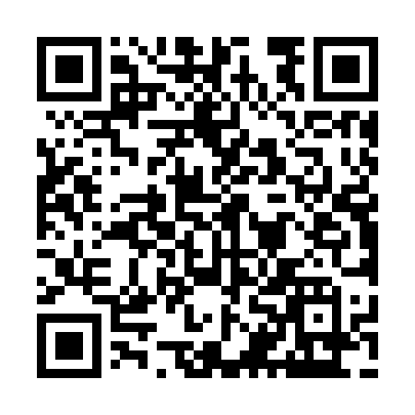
Prayer times for Genevrier-Farm, Quebec, Canada
Mon 1 Jul 2024 - Wed 31 Jul 2024
High Latitude Method: Angle Based Rule
Prayer Calculation Method: Islamic Society of North America
Asar Calculation Method: Hanafi

Date | Day | Fajr | Sunrise | Dhuhr | Asr | Maghrib | Isha
1 | Mon | 1:46 | 3:37 | 11:54 | 5:31 | 8:12 | 10:03
2 | Tue | 1:46 | 3:38 | 11:55 | 5:31 | 8:11 | 10:03
3 | Wed | 1:47 | 3:38 | 11:55 | 5:31 | 8:11 | 10:03
4 | Thu | 1:47 | 3:39 | 11:55 | 5:30 | 8:10 | 10:03
5 | Fri | 1:48 | 3:40 | 11:55 | 5:30 | 8:10 | 10:02
6 | Sat | 1:48 | 3:41 | 11:55 | 5:30 | 8:09 | 10:02
7 | Sun | 1:49 | 3:42 | 11:55 | 5:30 | 8:09 | 10:02
8 | Mon | 1:49 | 3:43 | 11:56 | 5:30 | 8:08 | 10:02
9 | Tue | 1:50 | 3:44 | 11:56 | 5:29 | 8:07 | 10:01
10 | Wed | 1:50 | 3:45 | 11:56 | 5:29 | 8:06 | 10:01
11 | Thu | 1:51 | 3:46 | 11:56 | 5:28 | 8:05 | 10:01
12 | Fri | 1:52 | 3:47 | 11:56 | 5:28 | 8:05 | 10:00
13 | Sat | 1:52 | 3:48 | 11:56 | 5:28 | 8:04 | 10:00
14 | Sun | 1:53 | 3:49 | 11:56 | 5:27 | 8:03 | 9:59
15 | Mon | 1:53 | 3:51 | 11:56 | 5:27 | 8:02 | 9:59
16 | Tue | 1:54 | 3:52 | 11:57 | 5:26 | 8:01 | 9:58
17 | Wed | 1:55 | 3:53 | 11:57 | 5:26 | 8:00 | 9:58
18 | Thu | 1:55 | 3:54 | 11:57 | 5:25 | 7:58 | 9:57
19 | Fri | 1:56 | 3:56 | 11:57 | 5:24 | 7:57 | 9:57
20 | Sat | 1:57 | 3:57 | 11:57 | 5:24 | 7:56 | 9:56
21 | Sun | 1:57 | 3:58 | 11:57 | 5:23 | 7:55 | 9:56
22 | Mon | 1:58 | 4:00 | 11:57 | 5:22 | 7:53 | 9:55
23 | Tue | 1:59 | 4:01 | 11:57 | 5:21 | 7:52 | 9:54
24 | Wed | 2:00 | 4:03 | 11:57 | 5:21 | 7:51 | 9:54
25 | Thu | 2:00 | 4:04 | 11:57 | 5:20 | 7:49 | 9:53
26 | Fri | 2:01 | 4:05 | 11:57 | 5:19 | 7:48 | 9:52
27 | Sat | 2:02 | 4:07 | 11:57 | 5:18 | 7:46 | 9:51
28 | Sun | 2:02 | 4:08 | 11:57 | 5:17 | 7:45 | 9:51
29 | Mon | 2:03 | 4:10 | 11:57 | 5:16 | 7:43 | 9:50
30 | Tue | 2:04 | 4:11 | 11:57 | 5:15 | 7:42 | 9:49
31 | Wed | 2:05 | 4:13 | 11:57 | 5:14 | 7:40 | 9:48
Prayer times provided by https://www.salahtimes.com

