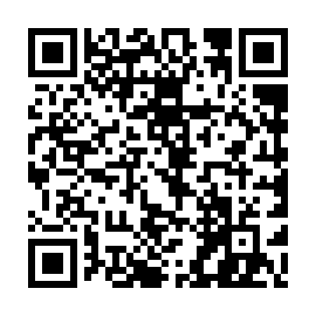
Prayer times for Val-Marguerite, Quebec, Canada
Mon 1 Apr 2024 - Tue 30 Apr 2024
High Latitude Method: Angle Based Rule
Prayer Calculation Method: Islamic Society of North America
Asar Calculation Method: Hanafi

Date | Day | Fajr | Sunrise | Dhuhr | Asr | Maghrib | Isha
1 | Mon | 4:29 | 6:02 | 12:30 | 4:58 | 6:59 | 8:33
2 | Tue | 4:26 | 5:59 | 12:30 | 4:59 | 7:01 | 8:35
3 | Wed | 4:23 | 5:57 | 12:29 | 5:00 | 7:02 | 8:37
4 | Thu | 4:21 | 5:55 | 12:29 | 5:01 | 7:04 | 8:39
5 | Fri | 4:18 | 5:53 | 12:29 | 5:03 | 7:06 | 8:41
6 | Sat | 4:16 | 5:51 | 12:29 | 5:04 | 7:07 | 8:43
7 | Sun | 4:13 | 5:49 | 12:28 | 5:05 | 7:09 | 8:45
8 | Mon | 4:11 | 5:47 | 12:28 | 5:06 | 7:10 | 8:47
9 | Tue | 4:08 | 5:44 | 12:28 | 5:07 | 7:12 | 8:49
10 | Wed | 4:06 | 5:42 | 12:27 | 5:08 | 7:14 | 8:51
11 | Thu | 4:03 | 5:40 | 12:27 | 5:09 | 7:15 | 8:53
12 | Fri | 4:00 | 5:38 | 12:27 | 5:10 | 7:17 | 8:55
13 | Sat | 3:58 | 5:36 | 12:27 | 5:11 | 7:18 | 8:57
14 | Sun | 3:55 | 5:34 | 12:26 | 5:12 | 7:20 | 8:59
15 | Mon | 3:53 | 5:32 | 12:26 | 5:13 | 7:21 | 9:01
16 | Tue | 3:50 | 5:30 | 12:26 | 5:14 | 7:23 | 9:03
17 | Wed | 3:47 | 5:28 | 12:26 | 5:15 | 7:25 | 9:06
18 | Thu | 3:45 | 5:26 | 12:26 | 5:16 | 7:26 | 9:08
19 | Fri | 3:42 | 5:24 | 12:25 | 5:18 | 7:28 | 9:10
20 | Sat | 3:39 | 5:22 | 12:25 | 5:19 | 7:29 | 9:12
21 | Sun | 3:37 | 5:20 | 12:25 | 5:20 | 7:31 | 9:14
22 | Mon | 3:34 | 5:18 | 12:25 | 5:21 | 7:32 | 9:17
23 | Tue | 3:32 | 5:16 | 12:25 | 5:22 | 7:34 | 9:19
24 | Wed | 3:29 | 5:14 | 12:24 | 5:23 | 7:36 | 9:21
25 | Thu | 3:26 | 5:12 | 12:24 | 5:24 | 7:37 | 9:24
26 | Fri | 3:24 | 5:10 | 12:24 | 5:25 | 7:39 | 9:26
27 | Sat | 3:21 | 5:08 | 12:24 | 5:25 | 7:40 | 9:28
28 | Sun | 3:18 | 5:07 | 12:24 | 5:26 | 7:42 | 9:31
29 | Mon | 3:16 | 5:05 | 12:24 | 5:27 | 7:43 | 9:33
30 | Tue | 3:13 | 5:03 | 12:24 | 5:28 | 7:45 | 9:35
Prayer times provided by https://www.salahtimes.com

