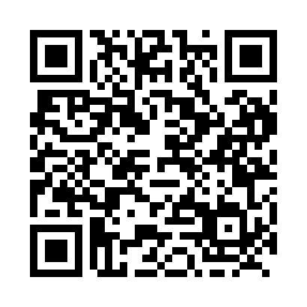
Prayer times for Ulkatcho, British Columbia, Canada
Wed 1 May 2024 - Fri 31 May 2024
High Latitude Method: Angle Based Rule
Prayer Calculation Method: Islamic Society of North America
Asar Calculation Method: Hanafi

Date | Day | Fajr | Sunrise | Dhuhr | Asr | Maghrib | Isha
1 | Wed | 3:44 | 5:48 | 1:20 | 6:29 | 8:52 | 10:58
2 | Thu | 3:40 | 5:46 | 1:20 | 6:30 | 8:54 | 11:01
3 | Fri | 3:37 | 5:44 | 1:20 | 6:31 | 8:56 | 11:04
4 | Sat | 3:34 | 5:42 | 1:20 | 6:32 | 8:58 | 11:07
5 | Sun | 3:30 | 5:41 | 1:19 | 6:33 | 8:59 | 11:10
6 | Mon | 3:29 | 5:39 | 1:19 | 6:34 | 9:01 | 11:10
7 | Tue | 3:28 | 5:37 | 1:19 | 6:35 | 9:03 | 11:11
8 | Wed | 3:27 | 5:35 | 1:19 | 6:36 | 9:04 | 11:12
9 | Thu | 3:26 | 5:33 | 1:19 | 6:37 | 9:06 | 11:13
10 | Fri | 3:26 | 5:32 | 1:19 | 6:38 | 9:08 | 11:14
11 | Sat | 3:25 | 5:30 | 1:19 | 6:39 | 9:09 | 11:14
12 | Sun | 3:24 | 5:28 | 1:19 | 6:40 | 9:11 | 11:15
13 | Mon | 3:23 | 5:26 | 1:19 | 6:41 | 9:13 | 11:16
14 | Tue | 3:22 | 5:25 | 1:19 | 6:42 | 9:14 | 11:17
15 | Wed | 3:21 | 5:23 | 1:19 | 6:43 | 9:16 | 11:18
16 | Thu | 3:21 | 5:22 | 1:19 | 6:44 | 9:17 | 11:19
17 | Fri | 3:20 | 5:20 | 1:19 | 6:45 | 9:19 | 11:19
18 | Sat | 3:19 | 5:19 | 1:19 | 6:46 | 9:21 | 11:20
19 | Sun | 3:19 | 5:17 | 1:19 | 6:47 | 9:22 | 11:21
20 | Mon | 3:18 | 5:16 | 1:19 | 6:48 | 9:24 | 11:22
21 | Tue | 3:17 | 5:15 | 1:19 | 6:49 | 9:25 | 11:22
22 | Wed | 3:17 | 5:13 | 1:20 | 6:49 | 9:27 | 11:23
23 | Thu | 3:16 | 5:12 | 1:20 | 6:50 | 9:28 | 11:24
24 | Fri | 3:15 | 5:11 | 1:20 | 6:51 | 9:29 | 11:25
25 | Sat | 3:15 | 5:10 | 1:20 | 6:52 | 9:31 | 11:25
26 | Sun | 3:14 | 5:08 | 1:20 | 6:53 | 9:32 | 11:26
27 | Mon | 3:14 | 5:07 | 1:20 | 6:53 | 9:33 | 11:27
28 | Tue | 3:13 | 5:06 | 1:20 | 6:54 | 9:35 | 11:28
29 | Wed | 3:13 | 5:05 | 1:20 | 6:55 | 9:36 | 11:28
30 | Thu | 3:13 | 5:04 | 1:20 | 6:56 | 9:37 | 11:29
31 | Fri | 3:12 | 5:03 | 1:21 | 6:56 | 9:38 | 11:30
Prayer times provided by https://www.salahtimes.com

