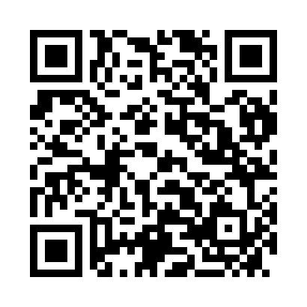
Prayer times for Neckenmarkt, Austria
Wed 1 May 2024 - Fri 31 May 2024
High Latitude Method: Angle Based Rule
Prayer Calculation Method: Muslim World League
Asar Calculation Method: Shafi

Date | Day | Fajr | Sunrise | Dhuhr | Asr | Maghrib | Isha
1 | Wed | 3:29 | 5:36 | 12:51 | 4:50 | 8:06 | 10:05
2 | Thu | 3:26 | 5:35 | 12:51 | 4:50 | 8:08 | 10:08
3 | Fri | 3:24 | 5:33 | 12:51 | 4:51 | 8:09 | 10:10
4 | Sat | 3:21 | 5:32 | 12:51 | 4:51 | 8:10 | 10:12
5 | Sun | 3:18 | 5:30 | 12:51 | 4:52 | 8:12 | 10:14
6 | Mon | 3:16 | 5:28 | 12:50 | 4:53 | 8:13 | 10:17
7 | Tue | 3:13 | 5:27 | 12:50 | 4:53 | 8:15 | 10:19
8 | Wed | 3:11 | 5:26 | 12:50 | 4:53 | 8:16 | 10:21
9 | Thu | 3:08 | 5:24 | 12:50 | 4:54 | 8:17 | 10:24
10 | Fri | 3:05 | 5:23 | 12:50 | 4:54 | 8:19 | 10:26
11 | Sat | 3:03 | 5:21 | 12:50 | 4:55 | 8:20 | 10:28
12 | Sun | 3:00 | 5:20 | 12:50 | 4:55 | 8:21 | 10:31
13 | Mon | 2:58 | 5:19 | 12:50 | 4:56 | 8:22 | 10:33
14 | Tue | 2:55 | 5:17 | 12:50 | 4:56 | 8:24 | 10:35
15 | Wed | 2:53 | 5:16 | 12:50 | 4:57 | 8:25 | 10:38
16 | Thu | 2:50 | 5:15 | 12:50 | 4:57 | 8:26 | 10:40
17 | Fri | 2:48 | 5:14 | 12:50 | 4:58 | 8:27 | 10:43
18 | Sat | 2:45 | 5:13 | 12:50 | 4:58 | 8:29 | 10:45
19 | Sun | 2:43 | 5:11 | 12:50 | 4:59 | 8:30 | 10:47
20 | Mon | 2:40 | 5:10 | 12:50 | 4:59 | 8:31 | 10:50
21 | Tue | 2:38 | 5:09 | 12:51 | 5:00 | 8:32 | 10:52
22 | Wed | 2:35 | 5:08 | 12:51 | 5:00 | 8:33 | 10:54
23 | Thu | 2:33 | 5:07 | 12:51 | 5:00 | 8:35 | 10:57
24 | Fri | 2:33 | 5:06 | 12:51 | 5:01 | 8:36 | 10:59
25 | Sat | 2:33 | 5:05 | 12:51 | 5:01 | 8:37 | 11:01
26 | Sun | 2:33 | 5:05 | 12:51 | 5:02 | 8:38 | 11:01
27 | Mon | 2:32 | 5:04 | 12:51 | 5:02 | 8:39 | 11:02
28 | Tue | 2:32 | 5:03 | 12:51 | 5:03 | 8:40 | 11:02
29 | Wed | 2:32 | 5:02 | 12:51 | 5:03 | 8:41 | 11:03
30 | Thu | 2:32 | 5:01 | 12:51 | 5:03 | 8:42 | 11:03
31 | Fri | 2:31 | 5:01 | 12:52 | 5:04 | 8:43 | 11:04
Prayer times provided by https://www.salahtimes.com

