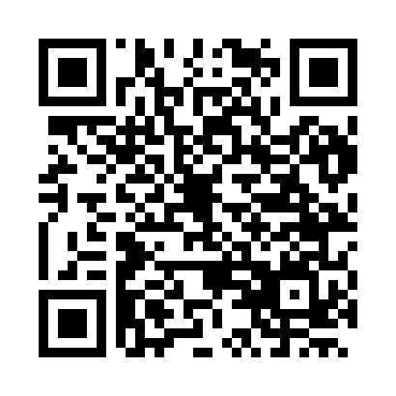
Prayer times for Limoges, Limousin, France
Wed 1 May 2024 - Fri 31 May 2024
High Latitude Method: Angle Based Rule
Prayer Calculation Method: Islamic Organisations Union of France
Asar Calculation Method: Shafi

Date | Day | Fajr | Sunrise | Dhuhr | Asr | Maghrib | Isha
1 | Wed | 5:28 | 6:42 | 1:52 | 5:49 | 9:03 | 10:17
2 | Thu | 5:26 | 6:40 | 1:52 | 5:50 | 9:04 | 10:19
3 | Fri | 5:24 | 6:39 | 1:52 | 5:50 | 9:06 | 10:21
4 | Sat | 5:22 | 6:37 | 1:52 | 5:51 | 9:07 | 10:22
5 | Sun | 5:20 | 6:36 | 1:52 | 5:51 | 9:08 | 10:24
6 | Mon | 5:18 | 6:34 | 1:52 | 5:51 | 9:09 | 10:26
7 | Tue | 5:17 | 6:33 | 1:51 | 5:52 | 9:11 | 10:27
8 | Wed | 5:15 | 6:32 | 1:51 | 5:52 | 9:12 | 10:29
9 | Thu | 5:13 | 6:30 | 1:51 | 5:53 | 9:13 | 10:31
10 | Fri | 5:11 | 6:29 | 1:51 | 5:53 | 9:14 | 10:32
11 | Sat | 5:10 | 6:28 | 1:51 | 5:54 | 9:16 | 10:34
12 | Sun | 5:08 | 6:26 | 1:51 | 5:54 | 9:17 | 10:36
13 | Mon | 5:06 | 6:25 | 1:51 | 5:54 | 9:18 | 10:37
14 | Tue | 5:05 | 6:24 | 1:51 | 5:55 | 9:19 | 10:39
15 | Wed | 5:03 | 6:23 | 1:51 | 5:55 | 9:20 | 10:40
16 | Thu | 5:02 | 6:22 | 1:51 | 5:56 | 9:22 | 10:42
17 | Fri | 5:00 | 6:21 | 1:51 | 5:56 | 9:23 | 10:44
18 | Sat | 4:59 | 6:20 | 1:51 | 5:57 | 9:24 | 10:45
19 | Sun | 4:57 | 6:19 | 1:51 | 5:57 | 9:25 | 10:47
20 | Mon | 4:56 | 6:18 | 1:52 | 5:57 | 9:26 | 10:48
21 | Tue | 4:54 | 6:17 | 1:52 | 5:58 | 9:27 | 10:50
22 | Wed | 4:53 | 6:16 | 1:52 | 5:58 | 9:28 | 10:51
23 | Thu | 4:52 | 6:15 | 1:52 | 5:59 | 9:29 | 10:53
24 | Fri | 4:50 | 6:14 | 1:52 | 5:59 | 9:30 | 10:54
25 | Sat | 4:49 | 6:13 | 1:52 | 5:59 | 9:31 | 10:55
26 | Sun | 4:48 | 6:12 | 1:52 | 6:00 | 9:32 | 10:57
27 | Mon | 4:47 | 6:11 | 1:52 | 6:00 | 9:33 | 10:58
28 | Tue | 4:46 | 6:11 | 1:52 | 6:01 | 9:34 | 11:00
29 | Wed | 4:45 | 6:10 | 1:52 | 6:01 | 9:35 | 11:01
30 | Thu | 4:44 | 6:09 | 1:53 | 6:01 | 9:36 | 11:02
31 | Fri | 4:43 | 6:09 | 1:53 | 6:02 | 9:37 | 11:03
Prayer times provided by https://www.salahtimes.com

