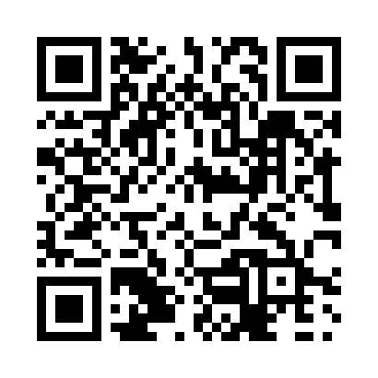
Prayer times for La Charge, Quebec, Canada
Mon 1 Jul 2024 - Wed 31 Jul 2024
High Latitude Method: Angle Based Rule
Prayer Calculation Method: Islamic Society of North America
Asar Calculation Method: Hanafi

Date | Day | Fajr | Sunrise | Dhuhr | Asr | Maghrib | Isha
1 | Mon | 2:47 | 4:49 | 12:46 | 6:12 | 8:42 | 10:44
2 | Tue | 2:48 | 4:50 | 12:46 | 6:12 | 8:41 | 10:43
3 | Wed | 2:48 | 4:51 | 12:46 | 6:12 | 8:41 | 10:43
4 | Thu | 2:49 | 4:51 | 12:46 | 6:12 | 8:41 | 10:43
5 | Fri | 2:49 | 4:52 | 12:46 | 6:12 | 8:40 | 10:43
6 | Sat | 2:50 | 4:53 | 12:46 | 6:12 | 8:40 | 10:43
7 | Sun | 2:50 | 4:54 | 12:47 | 6:12 | 8:39 | 10:43
8 | Mon | 2:50 | 4:54 | 12:47 | 6:12 | 8:39 | 10:43
9 | Tue | 2:51 | 4:55 | 12:47 | 6:11 | 8:38 | 10:42
10 | Wed | 2:52 | 4:56 | 12:47 | 6:11 | 8:38 | 10:41
11 | Thu | 2:54 | 4:57 | 12:47 | 6:11 | 8:37 | 10:40
12 | Fri | 2:55 | 4:58 | 12:47 | 6:10 | 8:36 | 10:38
13 | Sat | 2:57 | 4:59 | 12:47 | 6:10 | 8:35 | 10:37
14 | Sun | 2:59 | 5:00 | 12:47 | 6:10 | 8:35 | 10:35
15 | Mon | 3:01 | 5:01 | 12:48 | 6:09 | 8:34 | 10:34
16 | Tue | 3:02 | 5:02 | 12:48 | 6:09 | 8:33 | 10:32
17 | Wed | 3:04 | 5:03 | 12:48 | 6:08 | 8:32 | 10:30
18 | Thu | 3:06 | 5:04 | 12:48 | 6:08 | 8:31 | 10:29
19 | Fri | 3:08 | 5:05 | 12:48 | 6:07 | 8:30 | 10:27
20 | Sat | 3:10 | 5:06 | 12:48 | 6:07 | 8:29 | 10:25
21 | Sun | 3:12 | 5:07 | 12:48 | 6:06 | 8:28 | 10:23
22 | Mon | 3:13 | 5:08 | 12:48 | 6:06 | 8:27 | 10:22
23 | Tue | 3:15 | 5:10 | 12:48 | 6:05 | 8:26 | 10:20
24 | Wed | 3:17 | 5:11 | 12:48 | 6:04 | 8:25 | 10:18
25 | Thu | 3:19 | 5:12 | 12:48 | 6:04 | 8:24 | 10:16
26 | Fri | 3:21 | 5:13 | 12:48 | 6:03 | 8:22 | 10:14
27 | Sat | 3:23 | 5:14 | 12:48 | 6:02 | 8:21 | 10:12
28 | Sun | 3:25 | 5:16 | 12:48 | 6:02 | 8:20 | 10:10
29 | Mon | 3:27 | 5:17 | 12:48 | 6:01 | 8:19 | 10:08
30 | Tue | 3:29 | 5:18 | 12:48 | 6:00 | 8:17 | 10:06
31 | Wed | 3:31 | 5:19 | 12:48 | 5:59 | 8:16 | 10:04
Prayer times provided by https://www.salahtimes.com

