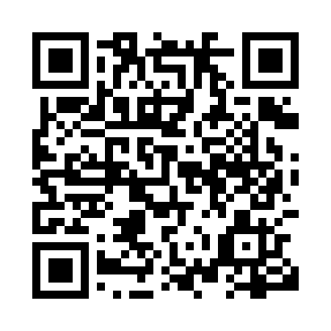
Prayer times for Forty Mile, Yukon, Canada
Wed 1 May 2024 - Fri 31 May 2024
High Latitude Method: Angle Based Rule
Prayer Calculation Method: Islamic Society of North America
Asar Calculation Method: Hanafi

Date | Day | Fajr | Sunrise | Dhuhr | Asr | Maghrib | Isha
1 | Wed | 4:05 | 5:49 | 2:19 | 7:45 | 10:51 | 12:35
2 | Thu | 4:03 | 5:46 | 2:19 | 7:46 | 10:54 | 12:37
3 | Fri | 4:01 | 5:42 | 2:19 | 7:48 | 10:57 | 12:39
4 | Sat | 3:59 | 5:39 | 2:19 | 7:50 | 11:01 | 12:40
5 | Sun | 3:57 | 5:35 | 2:19 | 7:52 | 11:04 | 12:42
6 | Mon | 3:56 | 5:32 | 2:19 | 7:53 | 11:07 | 12:43
7 | Tue | 3:54 | 5:28 | 2:19 | 7:55 | 11:11 | 12:45
8 | Wed | 3:52 | 5:25 | 2:19 | 7:57 | 11:14 | 12:47
9 | Thu | 3:50 | 5:21 | 2:19 | 7:58 | 11:17 | 12:48
10 | Fri | 3:49 | 5:18 | 2:19 | 8:00 | 11:21 | 12:50
11 | Sat | 3:47 | 5:15 | 2:19 | 8:01 | 11:24 | 12:52
12 | Sun | 3:45 | 5:11 | 2:19 | 8:03 | 11:27 | 12:53
13 | Mon | 3:44 | 5:08 | 2:19 | 8:05 | 11:31 | 12:55
14 | Tue | 3:42 | 5:05 | 2:19 | 8:06 | 11:34 | 12:57
15 | Wed | 3:40 | 5:01 | 2:19 | 8:08 | 11:37 | 12:58
16 | Thu | 3:39 | 4:58 | 2:19 | 8:09 | 11:41 | 1:00
17 | Fri | 3:37 | 4:55 | 2:19 | 8:11 | 11:44 | 1:02
18 | Sat | 3:35 | 4:51 | 2:19 | 8:12 | 11:48 | 1:04
19 | Sun | 3:34 | 4:48 | 2:19 | 8:13 | 11:51 | 1:05
20 | Mon | 3:32 | 4:45 | 2:19 | 8:15 | 11:54 | 1:07
21 | Tue | 3:31 | 4:42 | 2:19 | 8:16 | 11:57 | 1:09
22 | Wed | 3:29 | 4:39 | 2:19 | 8:17 | 12:01 | 1:10
23 | Thu | 3:28 | 4:36 | 2:19 | 8:19 | 12:04 | 1:12
24 | Fri | 3:26 | 4:32 | 2:19 | 8:20 | 12:07 | 1:14
25 | Sat | 3:25 | 4:29 | 2:19 | 8:21 | 12:11 | 1:15
26 | Sun | 3:23 | 4:26 | 2:19 | 8:23 | 12:14 | 1:17
27 | Mon | 3:22 | 4:24 | 2:19 | 8:24 | 12:17 | 1:19
28 | Tue | 3:20 | 4:21 | 2:20 | 8:25 | 12:20 | 1:20
29 | Wed | 3:19 | 4:18 | 2:20 | 8:26 | 12:23 | 1:22
30 | Thu | 3:18 | 4:15 | 2:20 | 8:27 | 12:26 | 1:23
31 | Fri | 3:17 | 4:12 | 2:20 | 8:28 | 12:29 | 1:25
Prayer times provided by https://www.salahtimes.com

