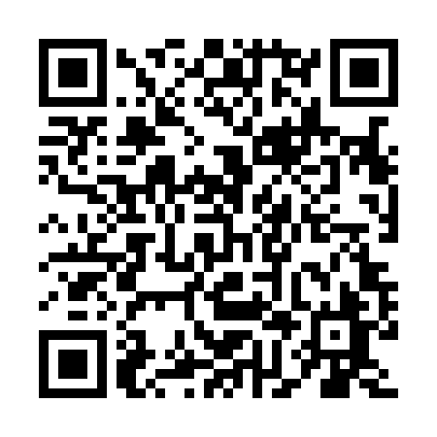
Prayer times for Fabre-Station, Quebec, Canada
Mon 1 Jul 2024 - Wed 31 Jul 2024
High Latitude Method: Angle Based Rule
Prayer Calculation Method: Islamic Society of North America
Asar Calculation Method: Hanafi

Date | Day | Fajr | Sunrise | Dhuhr | Asr | Maghrib | Isha
1 | Mon | 3:24 | 5:26 | 1:21 | 6:48 | 9:17 | 11:19
2 | Tue | 3:24 | 5:26 | 1:22 | 6:48 | 9:16 | 11:19
3 | Wed | 3:24 | 5:27 | 1:22 | 6:48 | 9:16 | 11:19
4 | Thu | 3:25 | 5:28 | 1:22 | 6:48 | 9:16 | 11:19
5 | Fri | 3:25 | 5:29 | 1:22 | 6:47 | 9:15 | 11:19
6 | Sat | 3:26 | 5:29 | 1:22 | 6:47 | 9:15 | 11:18
7 | Sun | 3:26 | 5:30 | 1:22 | 6:47 | 9:14 | 11:18
8 | Mon | 3:27 | 5:31 | 1:23 | 6:47 | 9:14 | 11:18
9 | Tue | 3:28 | 5:32 | 1:23 | 6:47 | 9:13 | 11:16
10 | Wed | 3:30 | 5:33 | 1:23 | 6:46 | 9:13 | 11:15
11 | Thu | 3:31 | 5:34 | 1:23 | 6:46 | 9:12 | 11:14
12 | Fri | 3:33 | 5:34 | 1:23 | 6:46 | 9:11 | 11:12
13 | Sat | 3:35 | 5:35 | 1:23 | 6:45 | 9:11 | 11:11
14 | Sun | 3:36 | 5:36 | 1:23 | 6:45 | 9:10 | 11:09
15 | Mon | 3:38 | 5:37 | 1:23 | 6:45 | 9:09 | 11:08
16 | Tue | 3:40 | 5:38 | 1:23 | 6:44 | 9:08 | 11:06
17 | Wed | 3:42 | 5:39 | 1:24 | 6:44 | 9:07 | 11:05
18 | Thu | 3:43 | 5:41 | 1:24 | 6:43 | 9:06 | 11:03
19 | Fri | 3:45 | 5:42 | 1:24 | 6:43 | 9:05 | 11:01
20 | Sat | 3:47 | 5:43 | 1:24 | 6:42 | 9:04 | 10:59
21 | Sun | 3:49 | 5:44 | 1:24 | 6:42 | 9:03 | 10:58
22 | Mon | 3:51 | 5:45 | 1:24 | 6:41 | 9:02 | 10:56
23 | Tue | 3:53 | 5:46 | 1:24 | 6:41 | 9:01 | 10:54
24 | Wed | 3:55 | 5:47 | 1:24 | 6:40 | 9:00 | 10:52
25 | Thu | 3:57 | 5:48 | 1:24 | 6:39 | 8:59 | 10:50
26 | Fri | 3:58 | 5:50 | 1:24 | 6:39 | 8:58 | 10:48
27 | Sat | 4:00 | 5:51 | 1:24 | 6:38 | 8:56 | 10:46
28 | Sun | 4:02 | 5:52 | 1:24 | 6:37 | 8:55 | 10:44
29 | Mon | 4:04 | 5:53 | 1:24 | 6:36 | 8:54 | 10:42
30 | Tue | 4:06 | 5:54 | 1:24 | 6:35 | 8:52 | 10:40
31 | Wed | 4:08 | 5:56 | 1:24 | 6:35 | 8:51 | 10:38
Prayer times provided by https://www.salahtimes.com

