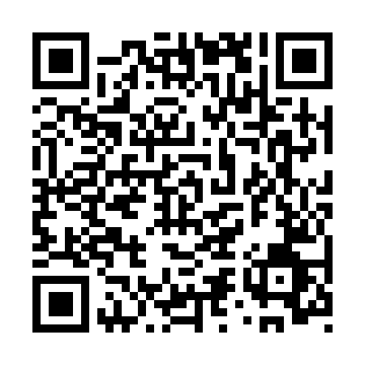
Prayer times for Coquimbito, Argentina
Wed 1 May 2024 - Fri 31 May 2024
High Latitude Method: None
Prayer Calculation Method: Muslim World League
Asar Calculation Method: Shafi

Date | Day | Fajr | Sunrise | Dhuhr | Asr | Maghrib | Isha
1 | Wed | 6:45 | 8:09 | 1:32 | 4:33 | 6:55 | 8:14
2 | Thu | 6:45 | 8:09 | 1:32 | 4:32 | 6:54 | 8:13
3 | Fri | 6:46 | 8:10 | 1:32 | 4:31 | 6:53 | 8:12
4 | Sat | 6:47 | 8:11 | 1:32 | 4:31 | 6:52 | 8:12
5 | Sun | 6:47 | 8:12 | 1:32 | 4:30 | 6:51 | 8:11
6 | Mon | 6:48 | 8:12 | 1:32 | 4:29 | 6:50 | 8:10
7 | Tue | 6:48 | 8:13 | 1:32 | 4:28 | 6:50 | 8:09
8 | Wed | 6:49 | 8:14 | 1:31 | 4:28 | 6:49 | 8:09
9 | Thu | 6:50 | 8:15 | 1:31 | 4:27 | 6:48 | 8:08
10 | Fri | 6:50 | 8:15 | 1:31 | 4:26 | 6:47 | 8:07
11 | Sat | 6:51 | 8:16 | 1:31 | 4:26 | 6:46 | 8:07
12 | Sun | 6:51 | 8:17 | 1:31 | 4:25 | 6:46 | 8:06
13 | Mon | 6:52 | 8:17 | 1:31 | 4:25 | 6:45 | 8:06
14 | Tue | 6:53 | 8:18 | 1:31 | 4:24 | 6:44 | 8:05
15 | Wed | 6:53 | 8:19 | 1:31 | 4:24 | 6:44 | 8:04
16 | Thu | 6:54 | 8:19 | 1:31 | 4:23 | 6:43 | 8:04
17 | Fri | 6:54 | 8:20 | 1:31 | 4:23 | 6:42 | 8:03
18 | Sat | 6:55 | 8:21 | 1:31 | 4:22 | 6:42 | 8:03
19 | Sun | 6:55 | 8:22 | 1:32 | 4:22 | 6:41 | 8:02
20 | Mon | 6:56 | 8:22 | 1:32 | 4:21 | 6:41 | 8:02
21 | Tue | 6:57 | 8:23 | 1:32 | 4:21 | 6:40 | 8:02
22 | Wed | 6:57 | 8:24 | 1:32 | 4:20 | 6:40 | 8:01
23 | Thu | 6:58 | 8:24 | 1:32 | 4:20 | 6:39 | 8:01
24 | Fri | 6:58 | 8:25 | 1:32 | 4:20 | 6:39 | 8:01
25 | Sat | 6:59 | 8:26 | 1:32 | 4:19 | 6:38 | 8:00
26 | Sun | 6:59 | 8:26 | 1:32 | 4:19 | 6:38 | 8:00
27 | Mon | 7:00 | 8:27 | 1:32 | 4:19 | 6:38 | 8:00
28 | Tue | 7:00 | 8:27 | 1:32 | 4:18 | 6:37 | 7:59
29 | Wed | 7:01 | 8:28 | 1:33 | 4:18 | 6:37 | 7:59
30 | Thu | 7:01 | 8:29 | 1:33 | 4:18 | 6:37 | 7:59
31 | Fri | 7:02 | 8:29 | 1:33 | 4:18 | 6:36 | 7:59
Prayer times provided by https://www.salahtimes.com

