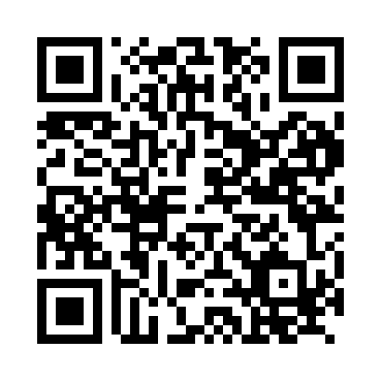
Prayer times for Almsick, Germany
Mon 1 Apr 2024 - Tue 30 Apr 2024
High Latitude Method: Angle Based Rule
Prayer Calculation Method: Muslim World League
Asar Calculation Method: Shafi

Date | Day | Fajr | Sunrise | Dhuhr | Asr | Maghrib | Isha
1 | Mon | 5:06 | 7:06 | 1:36 | 5:09 | 8:07 | 10:00
2 | Tue | 5:03 | 7:04 | 1:36 | 5:10 | 8:08 | 10:02
3 | Wed | 5:00 | 7:02 | 1:35 | 5:11 | 8:10 | 10:04
4 | Thu | 4:57 | 6:59 | 1:35 | 5:12 | 8:12 | 10:07
5 | Fri | 4:54 | 6:57 | 1:35 | 5:13 | 8:14 | 10:09
6 | Sat | 4:51 | 6:55 | 1:35 | 5:13 | 8:15 | 10:11
7 | Sun | 4:48 | 6:53 | 1:34 | 5:14 | 8:17 | 10:14
8 | Mon | 4:45 | 6:50 | 1:34 | 5:15 | 8:19 | 10:16
9 | Tue | 4:42 | 6:48 | 1:34 | 5:16 | 8:20 | 10:18
10 | Wed | 4:39 | 6:46 | 1:33 | 5:17 | 8:22 | 10:21
11 | Thu | 4:36 | 6:44 | 1:33 | 5:18 | 8:24 | 10:23
12 | Fri | 4:33 | 6:41 | 1:33 | 5:19 | 8:26 | 10:26
13 | Sat | 4:30 | 6:39 | 1:33 | 5:19 | 8:27 | 10:28
14 | Sun | 4:27 | 6:37 | 1:32 | 5:20 | 8:29 | 10:31
15 | Mon | 4:23 | 6:35 | 1:32 | 5:21 | 8:31 | 10:33
16 | Tue | 4:20 | 6:32 | 1:32 | 5:22 | 8:32 | 10:36
17 | Wed | 4:17 | 6:30 | 1:32 | 5:23 | 8:34 | 10:39
18 | Thu | 4:14 | 6:28 | 1:31 | 5:23 | 8:36 | 10:41
19 | Fri | 4:10 | 6:26 | 1:31 | 5:24 | 8:37 | 10:44
20 | Sat | 4:07 | 6:24 | 1:31 | 5:25 | 8:39 | 10:47
21 | Sun | 4:04 | 6:22 | 1:31 | 5:26 | 8:41 | 10:50
22 | Mon | 4:00 | 6:20 | 1:31 | 5:26 | 8:43 | 10:52
23 | Tue | 3:57 | 6:18 | 1:30 | 5:27 | 8:44 | 10:55
24 | Wed | 3:54 | 6:16 | 1:30 | 5:28 | 8:46 | 10:58
25 | Thu | 3:50 | 6:14 | 1:30 | 5:29 | 8:48 | 11:01
26 | Fri | 3:47 | 6:12 | 1:30 | 5:29 | 8:49 | 11:04
27 | Sat | 3:43 | 6:10 | 1:30 | 5:30 | 8:51 | 11:07
28 | Sun | 3:39 | 6:08 | 1:30 | 5:31 | 8:53 | 11:10
29 | Mon | 3:36 | 6:06 | 1:30 | 5:31 | 8:54 | 11:13
30 | Tue | 3:32 | 6:04 | 1:29 | 5:32 | 8:56 | 11:17
Prayer times provided by https://www.salahtimes.com

