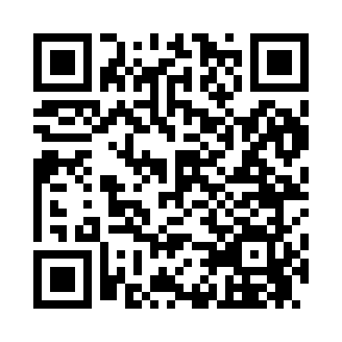
Prayer times for Coveville, New York, USA
Mon 1 Apr 2024 - Tue 30 Apr 2024
High Latitude Method: Angle Based Rule
Prayer Calculation Method: Islamic Society of North America
Asar Calculation Method: Shafi

Date | Day | Fajr | Sunrise | Dhuhr | Asr | Maghrib | Isha
1 | Mon | 5:15 | 6:35 | 12:58 | 4:33 | 7:21 | 8:42
2 | Tue | 5:13 | 6:34 | 12:58 | 4:34 | 7:23 | 8:43
3 | Wed | 5:11 | 6:32 | 12:57 | 4:34 | 7:24 | 8:45
4 | Thu | 5:09 | 6:30 | 12:57 | 4:35 | 7:25 | 8:46
5 | Fri | 5:07 | 6:28 | 12:57 | 4:35 | 7:26 | 8:47
6 | Sat | 5:05 | 6:27 | 12:57 | 4:36 | 7:27 | 8:49
7 | Sun | 5:03 | 6:25 | 12:56 | 4:36 | 7:28 | 8:50
8 | Mon | 5:01 | 6:23 | 12:56 | 4:37 | 7:30 | 8:52
9 | Tue | 5:00 | 6:22 | 12:56 | 4:37 | 7:31 | 8:53
10 | Wed | 4:58 | 6:20 | 12:56 | 4:37 | 7:32 | 8:54
11 | Thu | 4:56 | 6:18 | 12:55 | 4:38 | 7:33 | 8:56
12 | Fri | 4:54 | 6:17 | 12:55 | 4:38 | 7:34 | 8:57
13 | Sat | 4:52 | 6:15 | 12:55 | 4:39 | 7:35 | 8:59
14 | Sun | 4:50 | 6:13 | 12:54 | 4:39 | 7:36 | 9:00
15 | Mon | 4:48 | 6:12 | 12:54 | 4:40 | 7:38 | 9:02
16 | Tue | 4:46 | 6:10 | 12:54 | 4:40 | 7:39 | 9:03
17 | Wed | 4:44 | 6:08 | 12:54 | 4:40 | 7:40 | 9:05
18 | Thu | 4:42 | 6:07 | 12:54 | 4:41 | 7:41 | 9:06
19 | Fri | 4:40 | 6:05 | 12:53 | 4:41 | 7:42 | 9:08
20 | Sat | 4:38 | 6:04 | 12:53 | 4:42 | 7:43 | 9:09
21 | Sun | 4:36 | 6:02 | 12:53 | 4:42 | 7:45 | 9:11
22 | Mon | 4:34 | 6:00 | 12:53 | 4:42 | 7:46 | 9:12
23 | Tue | 4:32 | 5:59 | 12:53 | 4:43 | 7:47 | 9:14
24 | Wed | 4:30 | 5:57 | 12:52 | 4:43 | 7:48 | 9:15
25 | Thu | 4:28 | 5:56 | 12:52 | 4:43 | 7:49 | 9:17
26 | Fri | 4:27 | 5:54 | 12:52 | 4:44 | 7:50 | 9:18
27 | Sat | 4:25 | 5:53 | 12:52 | 4:44 | 7:52 | 9:20
28 | Sun | 4:23 | 5:52 | 12:52 | 4:45 | 7:53 | 9:22
29 | Mon | 4:21 | 5:50 | 12:52 | 4:45 | 7:54 | 9:23
30 | Tue | 4:19 | 5:49 | 12:52 | 4:45 | 7:55 | 9:25
Prayer times provided by https://www.salahtimes.com

