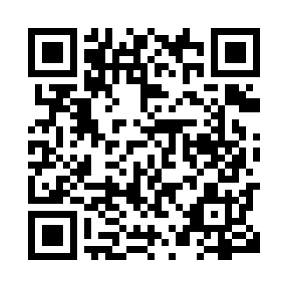
Prayer times for Atnarko, British Columbia, Canada
Mon 1 Apr 2024 - Tue 30 Apr 2024
High Latitude Method: Angle Based Rule
Prayer Calculation Method: Islamic Society of North America
Asar Calculation Method: Hanafi

Date | Day | Fajr | Sunrise | Dhuhr | Asr | Maghrib | Isha
1 | Mon | 5:17 | 6:56 | 1:27 | 5:54 | 7:59 | 9:38
2 | Tue | 5:15 | 6:54 | 1:27 | 5:56 | 8:01 | 9:40
3 | Wed | 5:12 | 6:51 | 1:26 | 5:57 | 8:02 | 9:42
4 | Thu | 5:09 | 6:49 | 1:26 | 5:58 | 8:04 | 9:44
5 | Fri | 5:06 | 6:47 | 1:26 | 5:59 | 8:06 | 9:47
6 | Sat | 5:03 | 6:44 | 1:26 | 6:01 | 8:08 | 9:49
7 | Sun | 5:01 | 6:42 | 1:25 | 6:02 | 8:09 | 9:51
8 | Mon | 4:58 | 6:40 | 1:25 | 6:03 | 8:11 | 9:54
9 | Tue | 4:55 | 6:38 | 1:25 | 6:04 | 8:13 | 9:56
10 | Wed | 4:52 | 6:35 | 1:24 | 6:05 | 8:15 | 9:58
11 | Thu | 4:49 | 6:33 | 1:24 | 6:07 | 8:16 | 10:01
12 | Fri | 4:46 | 6:31 | 1:24 | 6:08 | 8:18 | 10:03
13 | Sat | 4:43 | 6:29 | 1:24 | 6:09 | 8:20 | 10:05
14 | Sun | 4:41 | 6:26 | 1:23 | 6:10 | 8:21 | 10:08
15 | Mon | 4:38 | 6:24 | 1:23 | 6:11 | 8:23 | 10:10
16 | Tue | 4:35 | 6:22 | 1:23 | 6:12 | 8:25 | 10:13
17 | Wed | 4:32 | 6:20 | 1:23 | 6:14 | 8:27 | 10:15
18 | Thu | 4:29 | 6:18 | 1:22 | 6:15 | 8:28 | 10:18
19 | Fri | 4:26 | 6:15 | 1:22 | 6:16 | 8:30 | 10:20
20 | Sat | 4:23 | 6:13 | 1:22 | 6:17 | 8:32 | 10:23
21 | Sun | 4:20 | 6:11 | 1:22 | 6:18 | 8:34 | 10:25
22 | Mon | 4:17 | 6:09 | 1:22 | 6:19 | 8:35 | 10:28
23 | Tue | 4:14 | 6:07 | 1:22 | 6:20 | 8:37 | 10:31
24 | Wed | 4:11 | 6:05 | 1:21 | 6:22 | 8:39 | 10:33
25 | Thu | 4:08 | 6:03 | 1:21 | 6:23 | 8:41 | 10:36
26 | Fri | 4:05 | 6:01 | 1:21 | 6:24 | 8:42 | 10:39
27 | Sat | 4:02 | 5:59 | 1:21 | 6:25 | 8:44 | 10:42
28 | Sun | 3:59 | 5:57 | 1:21 | 6:26 | 8:46 | 10:44
29 | Mon | 3:56 | 5:55 | 1:21 | 6:27 | 8:47 | 10:47
30 | Tue | 3:53 | 5:53 | 1:20 | 6:28 | 8:49 | 10:50
Prayer times provided by https://www.salahtimes.com

