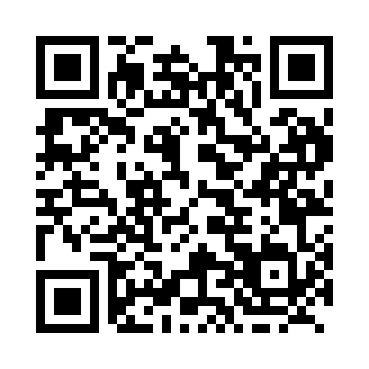
Prayer times for Uhakatshukua, Quebec, Canada
Mon 1 Apr 2024 - Tue 30 Apr 2024
High Latitude Method: Angle Based Rule
Prayer Calculation Method: Islamic Society of North America
Asar Calculation Method: Hanafi

Date | Day | Fajr | Sunrise | Dhuhr | Asr | Maghrib | Isha
1 | Mon | 3:53 | 5:28 | 11:58 | 4:25 | 6:28 | 8:04
2 | Tue | 3:50 | 5:26 | 11:57 | 4:26 | 6:30 | 8:06
3 | Wed | 3:48 | 5:24 | 11:57 | 4:28 | 6:31 | 8:08
4 | Thu | 3:45 | 5:22 | 11:57 | 4:29 | 6:33 | 8:10
5 | Fri | 3:42 | 5:19 | 11:57 | 4:30 | 6:35 | 8:12
6 | Sat | 3:40 | 5:17 | 11:56 | 4:31 | 6:36 | 8:14
7 | Sun | 3:37 | 5:15 | 11:56 | 4:32 | 6:38 | 8:16
8 | Mon | 3:34 | 5:13 | 11:56 | 4:34 | 6:40 | 8:19
9 | Tue | 3:32 | 5:11 | 11:55 | 4:35 | 6:41 | 8:21
10 | Wed | 3:29 | 5:08 | 11:55 | 4:36 | 6:43 | 8:23
11 | Thu | 3:26 | 5:06 | 11:55 | 4:37 | 6:45 | 8:25
12 | Fri | 3:23 | 5:04 | 11:55 | 4:38 | 6:46 | 8:27
13 | Sat | 3:21 | 5:02 | 11:54 | 4:39 | 6:48 | 8:30
14 | Sun | 3:18 | 5:00 | 11:54 | 4:40 | 6:50 | 8:32
15 | Mon | 3:15 | 4:58 | 11:54 | 4:41 | 6:51 | 8:34
16 | Tue | 3:12 | 4:56 | 11:54 | 4:43 | 6:53 | 8:36
17 | Wed | 3:10 | 4:53 | 11:54 | 4:44 | 6:54 | 8:39
18 | Thu | 3:07 | 4:51 | 11:53 | 4:45 | 6:56 | 8:41
19 | Fri | 3:04 | 4:49 | 11:53 | 4:46 | 6:58 | 8:43
20 | Sat | 3:01 | 4:47 | 11:53 | 4:47 | 6:59 | 8:46
21 | Sun | 2:59 | 4:45 | 11:53 | 4:48 | 7:01 | 8:48
22 | Mon | 2:56 | 4:43 | 11:52 | 4:49 | 7:03 | 8:51
23 | Tue | 2:53 | 4:41 | 11:52 | 4:50 | 7:04 | 8:53
24 | Wed | 2:50 | 4:39 | 11:52 | 4:51 | 7:06 | 8:56
25 | Thu | 2:47 | 4:37 | 11:52 | 4:52 | 7:08 | 8:58
26 | Fri | 2:45 | 4:35 | 11:52 | 4:53 | 7:09 | 9:00
27 | Sat | 2:42 | 4:33 | 11:52 | 4:54 | 7:11 | 9:03
28 | Sun | 2:39 | 4:31 | 11:51 | 4:55 | 7:13 | 9:06
29 | Mon | 2:36 | 4:29 | 11:51 | 4:56 | 7:14 | 9:08
30 | Tue | 2:33 | 4:28 | 11:51 | 4:57 | 7:16 | 9:11
Prayer times provided by https://www.salahtimes.com

