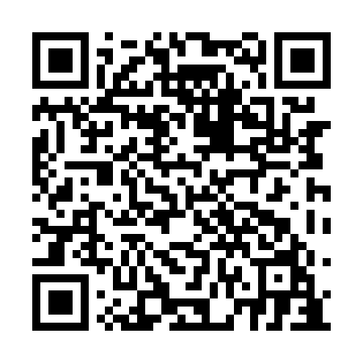
Prayer times for Campbell's Corner, Quebec, Canada
Mon 1 Apr 2024 - Tue 30 Apr 2024
High Latitude Method: Angle Based Rule
Prayer Calculation Method: Islamic Society of North America
Asar Calculation Method: Hanafi

Date | Day | Fajr | Sunrise | Dhuhr | Asr | Maghrib | Isha
1 | Mon | 4:59 | 6:25 | 12:50 | 5:19 | 7:16 | 8:41
2 | Tue | 4:57 | 6:23 | 12:49 | 5:20 | 7:17 | 8:43
3 | Wed | 4:55 | 6:21 | 12:49 | 5:21 | 7:18 | 8:44
4 | Thu | 4:53 | 6:19 | 12:49 | 5:22 | 7:20 | 8:46
5 | Fri | 4:50 | 6:17 | 12:49 | 5:23 | 7:21 | 8:48
6 | Sat | 4:48 | 6:15 | 12:48 | 5:23 | 7:22 | 8:49
7 | Sun | 4:46 | 6:13 | 12:48 | 5:24 | 7:24 | 8:51
8 | Mon | 4:44 | 6:11 | 12:48 | 5:25 | 7:25 | 8:53
9 | Tue | 4:42 | 6:09 | 12:47 | 5:26 | 7:26 | 8:54
10 | Wed | 4:39 | 6:08 | 12:47 | 5:27 | 7:28 | 8:56
11 | Thu | 4:37 | 6:06 | 12:47 | 5:28 | 7:29 | 8:58
12 | Fri | 4:35 | 6:04 | 12:47 | 5:29 | 7:30 | 8:59
13 | Sat | 4:33 | 6:02 | 12:46 | 5:30 | 7:32 | 9:01
14 | Sun | 4:31 | 6:00 | 12:46 | 5:31 | 7:33 | 9:03
15 | Mon | 4:28 | 5:58 | 12:46 | 5:32 | 7:34 | 9:04
16 | Tue | 4:26 | 5:57 | 12:46 | 5:32 | 7:36 | 9:06
17 | Wed | 4:24 | 5:55 | 12:45 | 5:33 | 7:37 | 9:08
18 | Thu | 4:22 | 5:53 | 12:45 | 5:34 | 7:38 | 9:10
19 | Fri | 4:20 | 5:51 | 12:45 | 5:35 | 7:40 | 9:12
20 | Sat | 4:17 | 5:49 | 12:45 | 5:36 | 7:41 | 9:13
21 | Sun | 4:15 | 5:48 | 12:45 | 5:37 | 7:42 | 9:15
22 | Mon | 4:13 | 5:46 | 12:44 | 5:38 | 7:44 | 9:17
23 | Tue | 4:11 | 5:44 | 12:44 | 5:38 | 7:45 | 9:19
24 | Wed | 4:09 | 5:43 | 12:44 | 5:39 | 7:46 | 9:21
25 | Thu | 4:06 | 5:41 | 12:44 | 5:40 | 7:48 | 9:22
26 | Fri | 4:04 | 5:39 | 12:44 | 5:41 | 7:49 | 9:24
27 | Sat | 4:02 | 5:38 | 12:44 | 5:42 | 7:50 | 9:26
28 | Sun | 4:00 | 5:36 | 12:43 | 5:42 | 7:51 | 9:28
29 | Mon | 3:58 | 5:34 | 12:43 | 5:43 | 7:53 | 9:30
30 | Tue | 3:56 | 5:33 | 12:43 | 5:44 | 7:54 | 9:32
Prayer times provided by https://www.salahtimes.com

