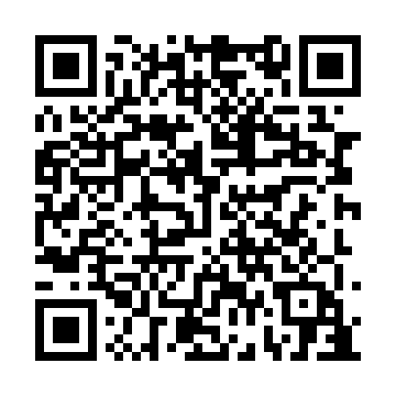
Prayer times for Twin Lakes Beach, Manitoba, Canada
Wed 1 May 2024 - Fri 31 May 2024
High Latitude Method: Angle Based Rule
Prayer Calculation Method: Islamic Society of North America
Asar Calculation Method: Hanafi

Date | Day | Fajr | Sunrise | Dhuhr | Asr | Maghrib | Isha
1 | Wed | 4:14 | 6:06 | 1:29 | 6:35 | 8:53 | 10:45
2 | Thu | 4:12 | 6:04 | 1:29 | 6:36 | 8:54 | 10:47
3 | Fri | 4:09 | 6:02 | 1:29 | 6:37 | 8:56 | 10:50
4 | Sat | 4:06 | 6:01 | 1:29 | 6:38 | 8:57 | 10:52
5 | Sun | 4:04 | 5:59 | 1:29 | 6:39 | 8:59 | 10:55
6 | Mon | 4:01 | 5:57 | 1:28 | 6:40 | 9:00 | 10:57
7 | Tue | 3:58 | 5:56 | 1:28 | 6:41 | 9:02 | 11:00
8 | Wed | 3:56 | 5:54 | 1:28 | 6:42 | 9:03 | 11:02
9 | Thu | 3:53 | 5:53 | 1:28 | 6:43 | 9:05 | 11:05
10 | Fri | 3:50 | 5:51 | 1:28 | 6:43 | 9:06 | 11:07
11 | Sat | 3:48 | 5:49 | 1:28 | 6:44 | 9:08 | 11:10
12 | Sun | 3:45 | 5:48 | 1:28 | 6:45 | 9:09 | 11:13
13 | Mon | 3:43 | 5:47 | 1:28 | 6:46 | 9:11 | 11:15
14 | Tue | 3:40 | 5:45 | 1:28 | 6:47 | 9:12 | 11:18
15 | Wed | 3:37 | 5:44 | 1:28 | 6:48 | 9:14 | 11:20
16 | Thu | 3:35 | 5:42 | 1:28 | 6:49 | 9:15 | 11:22
17 | Fri | 3:35 | 5:41 | 1:28 | 6:49 | 9:16 | 11:22
18 | Sat | 3:34 | 5:40 | 1:28 | 6:50 | 9:18 | 11:23
19 | Sun | 3:34 | 5:38 | 1:28 | 6:51 | 9:19 | 11:24
20 | Mon | 3:33 | 5:37 | 1:28 | 6:52 | 9:20 | 11:25
21 | Tue | 3:32 | 5:36 | 1:29 | 6:53 | 9:22 | 11:25
22 | Wed | 3:32 | 5:35 | 1:29 | 6:53 | 9:23 | 11:26
23 | Thu | 3:31 | 5:34 | 1:29 | 6:54 | 9:24 | 11:27
24 | Fri | 3:31 | 5:33 | 1:29 | 6:55 | 9:26 | 11:27
25 | Sat | 3:30 | 5:32 | 1:29 | 6:56 | 9:27 | 11:28
26 | Sun | 3:30 | 5:31 | 1:29 | 6:56 | 9:28 | 11:29
27 | Mon | 3:30 | 5:30 | 1:29 | 6:57 | 9:29 | 11:29
28 | Tue | 3:29 | 5:29 | 1:29 | 6:58 | 9:30 | 11:30
29 | Wed | 3:29 | 5:28 | 1:29 | 6:58 | 9:31 | 11:30
30 | Thu | 3:28 | 5:27 | 1:30 | 6:59 | 9:32 | 11:31
31 | Fri | 3:28 | 5:26 | 1:30 | 7:00 | 9:33 | 11:32
Prayer times provided by https://www.salahtimes.com

