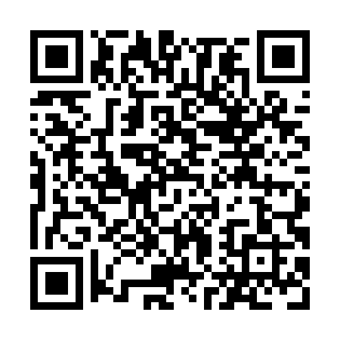
Prayer times for Bass River Point, New Brunswick, Canada
Wed 1 May 2024 - Fri 31 May 2024
High Latitude Method: Angle Based Rule
Prayer Calculation Method: Islamic Society of North America
Asar Calculation Method: Hanafi

Date | Day | Fajr | Sunrise | Dhuhr | Asr | Maghrib | Isha
1 | Wed | 4:26 | 6:05 | 1:17 | 6:19 | 8:30 | 10:09
2 | Thu | 4:24 | 6:03 | 1:17 | 6:20 | 8:32 | 10:11
3 | Fri | 4:22 | 6:02 | 1:17 | 6:21 | 8:33 | 10:13
4 | Sat | 4:20 | 6:00 | 1:17 | 6:22 | 8:34 | 10:15
5 | Sun | 4:18 | 5:59 | 1:17 | 6:22 | 8:36 | 10:17
6 | Mon | 4:16 | 5:57 | 1:17 | 6:23 | 8:37 | 10:19
7 | Tue | 4:14 | 5:56 | 1:17 | 6:24 | 8:38 | 10:21
8 | Wed | 4:12 | 5:55 | 1:17 | 6:25 | 8:39 | 10:23
9 | Thu | 4:10 | 5:53 | 1:17 | 6:25 | 8:41 | 10:25
10 | Fri | 4:08 | 5:52 | 1:17 | 6:26 | 8:42 | 10:27
11 | Sat | 4:06 | 5:51 | 1:17 | 6:27 | 8:43 | 10:29
12 | Sun | 4:04 | 5:49 | 1:17 | 6:28 | 8:44 | 10:30
13 | Mon | 4:02 | 5:48 | 1:17 | 6:28 | 8:46 | 10:32
14 | Tue | 4:00 | 5:47 | 1:17 | 6:29 | 8:47 | 10:34
15 | Wed | 3:58 | 5:46 | 1:17 | 6:30 | 8:48 | 10:36
16 | Thu | 3:56 | 5:44 | 1:17 | 6:31 | 8:49 | 10:38
17 | Fri | 3:54 | 5:43 | 1:17 | 6:31 | 8:51 | 10:40
18 | Sat | 3:52 | 5:42 | 1:17 | 6:32 | 8:52 | 10:42
19 | Sun | 3:51 | 5:41 | 1:17 | 6:33 | 8:53 | 10:44
20 | Mon | 3:49 | 5:40 | 1:17 | 6:33 | 8:54 | 10:46
21 | Tue | 3:47 | 5:39 | 1:17 | 6:34 | 8:55 | 10:47
22 | Wed | 3:46 | 5:38 | 1:17 | 6:35 | 8:56 | 10:49
23 | Thu | 3:44 | 5:37 | 1:17 | 6:35 | 8:57 | 10:51
24 | Fri | 3:42 | 5:36 | 1:17 | 6:36 | 8:58 | 10:53
25 | Sat | 3:41 | 5:35 | 1:17 | 6:37 | 8:59 | 10:55
26 | Sun | 3:39 | 5:35 | 1:17 | 6:37 | 9:00 | 10:56
27 | Mon | 3:38 | 5:34 | 1:17 | 6:38 | 9:01 | 10:58
28 | Tue | 3:36 | 5:33 | 1:18 | 6:39 | 9:02 | 11:00
29 | Wed | 3:35 | 5:32 | 1:18 | 6:39 | 9:03 | 11:01
30 | Thu | 3:34 | 5:32 | 1:18 | 6:40 | 9:04 | 11:03
31 | Fri | 3:32 | 5:31 | 1:18 | 6:40 | 9:05 | 11:04
Prayer times provided by https://www.salahtimes.com

