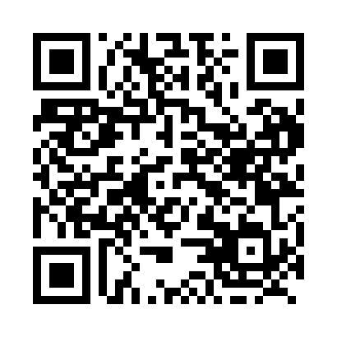
Prayer times for Barkmere, Quebec, Canada
Mon 1 Jul 2024 - Wed 31 Jul 2024
High Latitude Method: Angle Based Rule
Prayer Calculation Method: Islamic Society of North America
Asar Calculation Method: Hanafi

Date | Day | Fajr | Sunrise | Dhuhr | Asr | Maghrib | Isha
1 | Mon | 3:11 | 5:12 | 1:02 | 6:26 | 8:53 | 10:53
2 | Tue | 3:12 | 5:13 | 1:03 | 6:26 | 8:52 | 10:52
3 | Wed | 3:13 | 5:13 | 1:03 | 6:26 | 8:52 | 10:52
4 | Thu | 3:14 | 5:14 | 1:03 | 6:26 | 8:52 | 10:51
5 | Fri | 3:16 | 5:15 | 1:03 | 6:26 | 8:51 | 10:50
6 | Sat | 3:17 | 5:15 | 1:03 | 6:26 | 8:51 | 10:49
7 | Sun | 3:18 | 5:16 | 1:03 | 6:26 | 8:51 | 10:48
8 | Mon | 3:19 | 5:17 | 1:04 | 6:26 | 8:50 | 10:47
9 | Tue | 3:21 | 5:18 | 1:04 | 6:25 | 8:49 | 10:46
10 | Wed | 3:22 | 5:18 | 1:04 | 6:25 | 8:49 | 10:45
11 | Thu | 3:23 | 5:19 | 1:04 | 6:25 | 8:48 | 10:44
12 | Fri | 3:25 | 5:20 | 1:04 | 6:25 | 8:48 | 10:43
13 | Sat | 3:26 | 5:21 | 1:04 | 6:24 | 8:47 | 10:41
14 | Sun | 3:28 | 5:22 | 1:04 | 6:24 | 8:46 | 10:40
15 | Mon | 3:29 | 5:23 | 1:04 | 6:24 | 8:45 | 10:39
16 | Tue | 3:31 | 5:24 | 1:05 | 6:23 | 8:45 | 10:37
17 | Wed | 3:33 | 5:25 | 1:05 | 6:23 | 8:44 | 10:36
18 | Thu | 3:34 | 5:26 | 1:05 | 6:22 | 8:43 | 10:34
19 | Fri | 3:36 | 5:27 | 1:05 | 6:22 | 8:42 | 10:33
20 | Sat | 3:38 | 5:28 | 1:05 | 6:21 | 8:41 | 10:31
21 | Sun | 3:39 | 5:29 | 1:05 | 6:21 | 8:40 | 10:29
22 | Mon | 3:41 | 5:30 | 1:05 | 6:20 | 8:39 | 10:28
23 | Tue | 3:43 | 5:31 | 1:05 | 6:20 | 8:38 | 10:26
24 | Wed | 3:45 | 5:32 | 1:05 | 6:19 | 8:37 | 10:24
25 | Thu | 3:46 | 5:33 | 1:05 | 6:18 | 8:36 | 10:22
26 | Fri | 3:48 | 5:35 | 1:05 | 6:18 | 8:35 | 10:21
27 | Sat | 3:50 | 5:36 | 1:05 | 6:17 | 8:33 | 10:19
28 | Sun | 3:52 | 5:37 | 1:05 | 6:16 | 8:32 | 10:17
29 | Mon | 3:54 | 5:38 | 1:05 | 6:16 | 8:31 | 10:15
30 | Tue | 3:55 | 5:39 | 1:05 | 6:15 | 8:30 | 10:13
31 | Wed | 3:57 | 5:40 | 1:05 | 6:14 | 8:28 | 10:11
Prayer times provided by https://www.salahtimes.com

