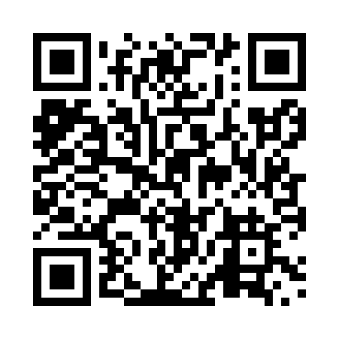
Prayer times for Arran, Saskatchewan, Canada
Wed 1 May 2024 - Fri 31 May 2024
High Latitude Method: Angle Based Rule
Prayer Calculation Method: Islamic Society of North America
Asar Calculation Method: Hanafi

Date | Day | Fajr | Sunrise | Dhuhr | Asr | Maghrib | Isha
1 | Wed | 3:18 | 5:16 | 12:44 | 5:52 | 8:13 | 10:12
2 | Thu | 3:15 | 5:14 | 12:44 | 5:53 | 8:14 | 10:15
3 | Fri | 3:12 | 5:12 | 12:44 | 5:54 | 8:16 | 10:17
4 | Sat | 3:09 | 5:11 | 12:44 | 5:55 | 8:17 | 10:20
5 | Sun | 3:06 | 5:09 | 12:44 | 5:56 | 8:19 | 10:23
6 | Mon | 3:03 | 5:07 | 12:43 | 5:57 | 8:21 | 10:26
7 | Tue | 2:59 | 5:05 | 12:43 | 5:58 | 8:22 | 10:29
8 | Wed | 2:56 | 5:04 | 12:43 | 5:59 | 8:24 | 10:32
9 | Thu | 2:53 | 5:02 | 12:43 | 6:00 | 8:26 | 10:35
10 | Fri | 2:52 | 5:00 | 12:43 | 6:01 | 8:27 | 10:35
11 | Sat | 2:51 | 4:59 | 12:43 | 6:02 | 8:29 | 10:36
12 | Sun | 2:50 | 4:57 | 12:43 | 6:03 | 8:30 | 10:37
13 | Mon | 2:50 | 4:55 | 12:43 | 6:04 | 8:32 | 10:38
14 | Tue | 2:49 | 4:54 | 12:43 | 6:04 | 8:33 | 10:39
15 | Wed | 2:48 | 4:52 | 12:43 | 6:05 | 8:35 | 10:39
16 | Thu | 2:47 | 4:51 | 12:43 | 6:06 | 8:36 | 10:40
17 | Fri | 2:47 | 4:49 | 12:43 | 6:07 | 8:38 | 10:41
18 | Sat | 2:46 | 4:48 | 12:43 | 6:08 | 8:39 | 10:42
19 | Sun | 2:45 | 4:47 | 12:43 | 6:09 | 8:41 | 10:42
20 | Mon | 2:45 | 4:45 | 12:43 | 6:10 | 8:42 | 10:43
21 | Tue | 2:44 | 4:44 | 12:44 | 6:10 | 8:44 | 10:44
22 | Wed | 2:43 | 4:43 | 12:44 | 6:11 | 8:45 | 10:44
23 | Thu | 2:43 | 4:42 | 12:44 | 6:12 | 8:46 | 10:45
24 | Fri | 2:42 | 4:41 | 12:44 | 6:13 | 8:48 | 10:46
25 | Sat | 2:42 | 4:39 | 12:44 | 6:14 | 8:49 | 10:47
26 | Sun | 2:41 | 4:38 | 12:44 | 6:14 | 8:50 | 10:47
27 | Mon | 2:41 | 4:37 | 12:44 | 6:15 | 8:52 | 10:48
28 | Tue | 2:40 | 4:36 | 12:44 | 6:16 | 8:53 | 10:49
29 | Wed | 2:40 | 4:35 | 12:44 | 6:17 | 8:54 | 10:49
30 | Thu | 2:40 | 4:34 | 12:45 | 6:17 | 8:55 | 10:50
31 | Fri | 2:39 | 4:34 | 12:45 | 6:18 | 8:56 | 10:51
Prayer times provided by https://www.salahtimes.com

