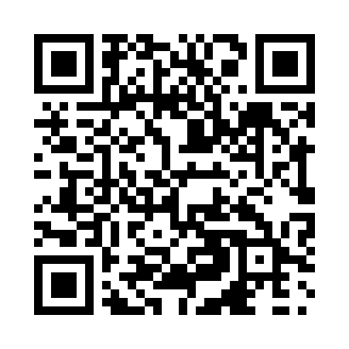
Prayer times for Brown's Arm, Newfoundland and Labrador, Canada
Mon 1 Jul 2024 - Wed 31 Jul 2024
High Latitude Method: Angle Based Rule
Prayer Calculation Method: Islamic Society of North America
Asar Calculation Method: Hanafi

Date | Day | Fajr | Sunrise | Dhuhr | Asr | Maghrib | Isha
1 | Mon | 3:12 | 5:10 | 1:15 | 6:46 | 9:19 | 11:17
2 | Tue | 3:13 | 5:10 | 1:15 | 6:46 | 9:19 | 11:17
3 | Wed | 3:13 | 5:11 | 1:15 | 6:45 | 9:19 | 11:17
4 | Thu | 3:14 | 5:12 | 1:15 | 6:45 | 9:18 | 11:17
5 | Fri | 3:14 | 5:13 | 1:15 | 6:45 | 9:18 | 11:17
6 | Sat | 3:14 | 5:14 | 1:16 | 6:45 | 9:17 | 11:16
7 | Sun | 3:15 | 5:14 | 1:16 | 6:45 | 9:17 | 11:16
8 | Mon | 3:15 | 5:15 | 1:16 | 6:45 | 9:16 | 11:16
9 | Tue | 3:16 | 5:16 | 1:16 | 6:44 | 9:16 | 11:16
10 | Wed | 3:17 | 5:17 | 1:16 | 6:44 | 9:15 | 11:15
11 | Thu | 3:17 | 5:18 | 1:16 | 6:44 | 9:14 | 11:15
12 | Fri | 3:18 | 5:19 | 1:16 | 6:43 | 9:13 | 11:15
13 | Sat | 3:18 | 5:20 | 1:17 | 6:43 | 9:13 | 11:14
14 | Sun | 3:19 | 5:21 | 1:17 | 6:42 | 9:12 | 11:14
15 | Mon | 3:19 | 5:22 | 1:17 | 6:42 | 9:11 | 11:14
16 | Tue | 3:20 | 5:23 | 1:17 | 6:42 | 9:10 | 11:13
17 | Wed | 3:21 | 5:24 | 1:17 | 6:41 | 9:09 | 11:13
18 | Thu | 3:21 | 5:26 | 1:17 | 6:41 | 9:08 | 11:12
19 | Fri | 3:22 | 5:27 | 1:17 | 6:40 | 9:07 | 11:12
20 | Sat | 3:22 | 5:28 | 1:17 | 6:39 | 9:06 | 11:11
21 | Sun | 3:23 | 5:29 | 1:17 | 6:39 | 9:05 | 11:10
22 | Mon | 3:25 | 5:30 | 1:17 | 6:38 | 9:03 | 11:08
23 | Tue | 3:27 | 5:32 | 1:17 | 6:37 | 9:02 | 11:06
24 | Wed | 3:30 | 5:33 | 1:17 | 6:37 | 9:01 | 11:03
25 | Thu | 3:32 | 5:34 | 1:17 | 6:36 | 9:00 | 11:01
26 | Fri | 3:34 | 5:35 | 1:17 | 6:35 | 8:58 | 10:59
27 | Sat | 3:37 | 5:37 | 1:17 | 6:34 | 8:57 | 10:57
28 | Sun | 3:39 | 5:38 | 1:17 | 6:34 | 8:56 | 10:54
29 | Mon | 3:41 | 5:39 | 1:17 | 6:33 | 8:54 | 10:52
30 | Tue | 3:44 | 5:41 | 1:17 | 6:32 | 8:53 | 10:49
31 | Wed | 3:46 | 5:42 | 1:17 | 6:31 | 8:51 | 10:47
Prayer times provided by https://www.salahtimes.com

