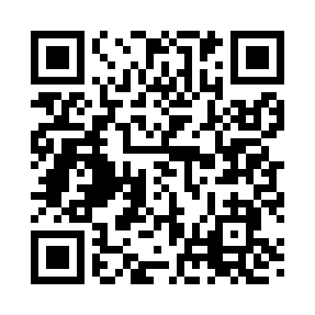
Prayer times for Morattico, Virginia, USA
Mon 1 Jul 2024 - Wed 31 Jul 2024
High Latitude Method: Angle Based Rule
Prayer Calculation Method: Islamic Society of North America
Asar Calculation Method: Shafi

Date | Day | Fajr | Sunrise | Dhuhr | Asr | Maghrib | Isha
1 | Mon | 4:17 | 5:49 | 1:11 | 5:04 | 8:32 | 10:04
2 | Tue | 4:18 | 5:49 | 1:11 | 5:04 | 8:32 | 10:03
3 | Wed | 4:19 | 5:50 | 1:11 | 5:05 | 8:32 | 10:03
4 | Thu | 4:19 | 5:50 | 1:11 | 5:05 | 8:32 | 10:03
5 | Fri | 4:20 | 5:51 | 1:11 | 5:05 | 8:32 | 10:02
6 | Sat | 4:21 | 5:51 | 1:11 | 5:05 | 8:31 | 10:02
7 | Sun | 4:22 | 5:52 | 1:12 | 5:05 | 8:31 | 10:01
8 | Mon | 4:22 | 5:52 | 1:12 | 5:05 | 8:31 | 10:01
9 | Tue | 4:23 | 5:53 | 1:12 | 5:05 | 8:31 | 10:00
10 | Wed | 4:24 | 5:54 | 1:12 | 5:05 | 8:30 | 10:00
11 | Thu | 4:25 | 5:54 | 1:12 | 5:05 | 8:30 | 9:59
12 | Fri | 4:26 | 5:55 | 1:12 | 5:05 | 8:29 | 9:58
13 | Sat | 4:27 | 5:56 | 1:12 | 5:05 | 8:29 | 9:58
14 | Sun | 4:28 | 5:56 | 1:12 | 5:05 | 8:28 | 9:57
15 | Mon | 4:29 | 5:57 | 1:13 | 5:05 | 8:28 | 9:56
16 | Tue | 4:30 | 5:58 | 1:13 | 5:05 | 8:27 | 9:55
17 | Wed | 4:31 | 5:58 | 1:13 | 5:05 | 8:27 | 9:54
18 | Thu | 4:32 | 5:59 | 1:13 | 5:05 | 8:26 | 9:53
19 | Fri | 4:33 | 6:00 | 1:13 | 5:05 | 8:25 | 9:53
20 | Sat | 4:34 | 6:01 | 1:13 | 5:05 | 8:25 | 9:52
21 | Sun | 4:35 | 6:02 | 1:13 | 5:05 | 8:24 | 9:51
22 | Mon | 4:36 | 6:02 | 1:13 | 5:05 | 8:23 | 9:50
23 | Tue | 4:37 | 6:03 | 1:13 | 5:05 | 8:23 | 9:48
24 | Wed | 4:38 | 6:04 | 1:13 | 5:05 | 8:22 | 9:47
25 | Thu | 4:39 | 6:05 | 1:13 | 5:04 | 8:21 | 9:46
26 | Fri | 4:40 | 6:06 | 1:13 | 5:04 | 8:20 | 9:45
27 | Sat | 4:42 | 6:06 | 1:13 | 5:04 | 8:19 | 9:44
28 | Sun | 4:43 | 6:07 | 1:13 | 5:04 | 8:18 | 9:43
29 | Mon | 4:44 | 6:08 | 1:13 | 5:04 | 8:18 | 9:42
30 | Tue | 4:45 | 6:09 | 1:13 | 5:03 | 8:17 | 9:40
31 | Wed | 4:46 | 6:10 | 1:13 | 5:03 | 8:16 | 9:39
Prayer times provided by https://www.salahtimes.com

