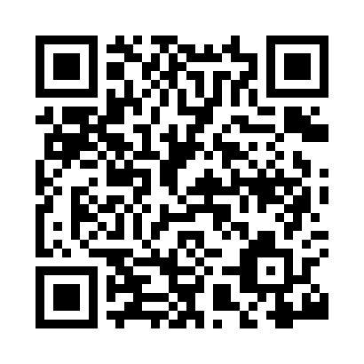
Prayer times for Tresta, Shetlands Islands, UK
Mon 1 Jul 2024 - Wed 31 Jul 2024
High Latitude Method: Angle Based Rule
Prayer Calculation Method: Islamic Society of North America
Asar Calculation Method: Hanafi

Date | Day | Fajr | Sunrise | Dhuhr | Asr | Maghrib | Isha
1 | Mon | 2:27 | 3:46 | 1:09 | 7:09 | 10:33 | 11:51
2 | Tue | 2:28 | 3:47 | 1:10 | 7:09 | 10:32 | 11:51
3 | Wed | 2:29 | 3:48 | 1:10 | 7:08 | 10:31 | 11:50
4 | Thu | 2:29 | 3:49 | 1:10 | 7:08 | 10:30 | 11:50
5 | Fri | 2:30 | 3:51 | 1:10 | 7:08 | 10:29 | 11:49
6 | Sat | 2:31 | 3:52 | 1:10 | 7:07 | 10:28 | 11:49
7 | Sun | 2:32 | 3:54 | 1:10 | 7:07 | 10:26 | 11:48
8 | Mon | 2:33 | 3:55 | 1:11 | 7:06 | 10:25 | 11:48
9 | Tue | 2:34 | 3:57 | 1:11 | 7:06 | 10:24 | 11:47
10 | Wed | 2:35 | 3:59 | 1:11 | 7:05 | 10:22 | 11:46
11 | Thu | 2:35 | 4:00 | 1:11 | 7:05 | 10:21 | 11:46
12 | Fri | 2:36 | 4:02 | 1:11 | 7:04 | 10:19 | 11:45
13 | Sat | 2:37 | 4:04 | 1:11 | 7:03 | 10:18 | 11:44
14 | Sun | 2:38 | 4:06 | 1:11 | 7:03 | 10:16 | 11:43
15 | Mon | 2:39 | 4:08 | 1:11 | 7:02 | 10:14 | 11:43
16 | Tue | 2:40 | 4:10 | 1:12 | 7:01 | 10:12 | 11:42
17 | Wed | 2:42 | 4:12 | 1:12 | 7:00 | 10:10 | 11:41
18 | Thu | 2:43 | 4:14 | 1:12 | 6:59 | 10:08 | 11:40
19 | Fri | 2:44 | 4:16 | 1:12 | 6:58 | 10:06 | 11:39
20 | Sat | 2:45 | 4:18 | 1:12 | 6:57 | 10:04 | 11:38
21 | Sun | 2:46 | 4:20 | 1:12 | 6:56 | 10:02 | 11:37
22 | Mon | 2:47 | 4:23 | 1:12 | 6:55 | 10:00 | 11:36
23 | Tue | 2:48 | 4:25 | 1:12 | 6:54 | 9:58 | 11:35
24 | Wed | 2:49 | 4:27 | 1:12 | 6:53 | 9:56 | 11:34
25 | Thu | 2:50 | 4:29 | 1:12 | 6:52 | 9:53 | 11:32
26 | Fri | 2:52 | 4:32 | 1:12 | 6:51 | 9:51 | 11:31
27 | Sat | 2:53 | 4:34 | 1:12 | 6:50 | 9:49 | 11:30
28 | Sun | 2:54 | 4:36 | 1:12 | 6:48 | 9:46 | 11:29
29 | Mon | 2:55 | 4:39 | 1:12 | 6:47 | 9:44 | 11:28
30 | Tue | 2:56 | 4:41 | 1:12 | 6:46 | 9:41 | 11:26
31 | Wed | 2:57 | 4:43 | 1:12 | 6:44 | 9:39 | 11:25
Prayer times provided by https://www.salahtimes.com

