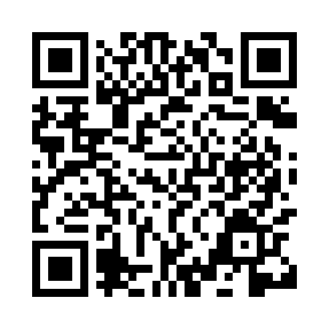
Prayer times for Nampho, North Korea
Wed 1 May 2024 - Fri 31 May 2024
High Latitude Method: None
Prayer Calculation Method: Muslim World League
Asar Calculation Method: Shafi

Date | Day | Fajr | Sunrise | Dhuhr | Asr | Maghrib | Isha
1 | Wed | 4:00 | 5:41 | 12:35 | 4:24 | 7:31 | 9:05
2 | Thu | 3:59 | 5:40 | 12:35 | 4:25 | 7:32 | 9:07
3 | Fri | 3:57 | 5:39 | 12:35 | 4:25 | 7:33 | 9:08
4 | Sat | 3:55 | 5:37 | 12:35 | 4:25 | 7:34 | 9:09
5 | Sun | 3:54 | 5:36 | 12:35 | 4:25 | 7:34 | 9:11
6 | Mon | 3:52 | 5:35 | 12:35 | 4:25 | 7:35 | 9:12
7 | Tue | 3:51 | 5:34 | 12:35 | 4:26 | 7:36 | 9:13
8 | Wed | 3:49 | 5:33 | 12:35 | 4:26 | 7:37 | 9:15
9 | Thu | 3:48 | 5:32 | 12:35 | 4:26 | 7:38 | 9:16
10 | Fri | 3:46 | 5:31 | 12:35 | 4:26 | 7:39 | 9:17
11 | Sat | 3:45 | 5:30 | 12:35 | 4:27 | 7:40 | 9:19
12 | Sun | 3:43 | 5:29 | 12:35 | 4:27 | 7:41 | 9:20
13 | Mon | 3:42 | 5:28 | 12:35 | 4:27 | 7:42 | 9:21
14 | Tue | 3:41 | 5:27 | 12:35 | 4:27 | 7:43 | 9:23
15 | Wed | 3:39 | 5:26 | 12:35 | 4:27 | 7:44 | 9:24
16 | Thu | 3:38 | 5:25 | 12:35 | 4:28 | 7:45 | 9:25
17 | Fri | 3:37 | 5:25 | 12:35 | 4:28 | 7:45 | 9:27
18 | Sat | 3:35 | 5:24 | 12:35 | 4:28 | 7:46 | 9:28
19 | Sun | 3:34 | 5:23 | 12:35 | 4:28 | 7:47 | 9:29
20 | Mon | 3:33 | 5:22 | 12:35 | 4:29 | 7:48 | 9:30
21 | Tue | 3:32 | 5:21 | 12:35 | 4:29 | 7:49 | 9:32
22 | Wed | 3:30 | 5:21 | 12:35 | 4:29 | 7:50 | 9:33
23 | Thu | 3:29 | 5:20 | 12:35 | 4:29 | 7:51 | 9:34
24 | Fri | 3:28 | 5:19 | 12:35 | 4:29 | 7:51 | 9:35
25 | Sat | 3:27 | 5:19 | 12:35 | 4:30 | 7:52 | 9:37
26 | Sun | 3:26 | 5:18 | 12:35 | 4:30 | 7:53 | 9:38
27 | Mon | 3:25 | 5:18 | 12:36 | 4:30 | 7:54 | 9:39
28 | Tue | 3:24 | 5:17 | 12:36 | 4:30 | 7:55 | 9:40
29 | Wed | 3:23 | 5:17 | 12:36 | 4:31 | 7:55 | 9:41
30 | Thu | 3:23 | 5:16 | 12:36 | 4:31 | 7:56 | 9:42
31 | Fri | 3:22 | 5:16 | 12:36 | 4:31 | 7:57 | 9:43
Prayer times provided by https://www.salahtimes.com

