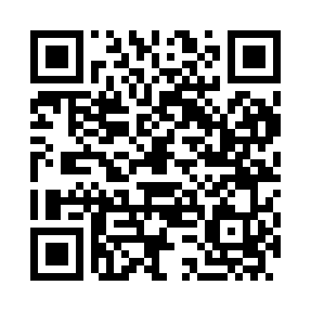
Prayer times for Chebba, Tunisia
Wed 1 May 2024 - Fri 31 May 2024
High Latitude Method: Angle Based Rule
Prayer Calculation Method: Tunisian Ministry of Religious Affairs
Asar Calculation Method: Shafi

Date | Day | Fajr | Sunrise | Dhuhr | Asr | Maghrib | Isha
1 | Wed | 3:50 | 5:24 | 12:13 | 3:57 | 7:02 | 8:36
2 | Thu | 3:48 | 5:23 | 12:13 | 3:57 | 7:03 | 8:37
3 | Fri | 3:47 | 5:22 | 12:12 | 3:57 | 7:03 | 8:39
4 | Sat | 3:46 | 5:21 | 12:12 | 3:57 | 7:04 | 8:40
5 | Sun | 3:44 | 5:20 | 12:12 | 3:57 | 7:05 | 8:41
6 | Mon | 3:43 | 5:19 | 12:12 | 3:58 | 7:06 | 8:42
7 | Tue | 3:42 | 5:18 | 12:12 | 3:58 | 7:07 | 8:43
8 | Wed | 3:40 | 5:17 | 12:12 | 3:58 | 7:07 | 8:44
9 | Thu | 3:39 | 5:16 | 12:12 | 3:58 | 7:08 | 8:46
10 | Fri | 3:38 | 5:15 | 12:12 | 3:58 | 7:09 | 8:47
11 | Sat | 3:37 | 5:14 | 12:12 | 3:58 | 7:10 | 8:48
12 | Sun | 3:35 | 5:14 | 12:12 | 3:58 | 7:11 | 8:49
13 | Mon | 3:34 | 5:13 | 12:12 | 3:58 | 7:11 | 8:50
14 | Tue | 3:33 | 5:12 | 12:12 | 3:59 | 7:12 | 8:51
15 | Wed | 3:32 | 5:11 | 12:12 | 3:59 | 7:13 | 8:53
16 | Thu | 3:31 | 5:11 | 12:12 | 3:59 | 7:14 | 8:54
17 | Fri | 3:30 | 5:10 | 12:12 | 3:59 | 7:15 | 8:55
18 | Sat | 3:29 | 5:09 | 12:12 | 3:59 | 7:15 | 8:56
19 | Sun | 3:28 | 5:08 | 12:12 | 3:59 | 7:16 | 8:57
20 | Mon | 3:27 | 5:08 | 12:12 | 3:59 | 7:17 | 8:58
21 | Tue | 3:26 | 5:07 | 12:12 | 3:59 | 7:18 | 8:59
22 | Wed | 3:25 | 5:07 | 12:12 | 4:00 | 7:18 | 9:00
23 | Thu | 3:24 | 5:06 | 12:12 | 4:00 | 7:19 | 9:01
24 | Fri | 3:23 | 5:05 | 12:13 | 4:00 | 7:20 | 9:02
25 | Sat | 3:22 | 5:05 | 12:13 | 4:00 | 7:21 | 9:04
26 | Sun | 3:21 | 5:04 | 12:13 | 4:00 | 7:21 | 9:05
27 | Mon | 3:21 | 5:04 | 12:13 | 4:00 | 7:22 | 9:06
28 | Tue | 3:20 | 5:04 | 12:13 | 4:01 | 7:23 | 9:07
29 | Wed | 3:19 | 5:03 | 12:13 | 4:01 | 7:23 | 9:07
30 | Thu | 3:18 | 5:03 | 12:13 | 4:01 | 7:24 | 9:08
31 | Fri | 3:18 | 5:02 | 12:13 | 4:01 | 7:25 | 9:09
Prayer times provided by https://www.salahtimes.com

