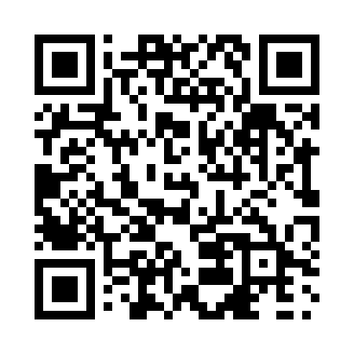
Prayer times for Yellowknife, Northwest Territories, Canada
Wed 1 May 2024 - Fri 31 May 2024
High Latitude Method: Angle Based Rule
Prayer Calculation Method: Islamic Society of North America
Asar Calculation Method: Hanafi

Date | Day | Fajr | Sunrise | Dhuhr | Asr | Maghrib | Isha
1 | Wed | 3:27 | 5:19 | 1:34 | 6:56 | 9:52 | 11:43
2 | Thu | 3:25 | 5:16 | 1:34 | 6:58 | 9:55 | 11:45
3 | Fri | 3:24 | 5:13 | 1:34 | 7:00 | 9:57 | 11:46
4 | Sat | 3:22 | 5:10 | 1:34 | 7:01 | 10:00 | 11:48
5 | Sun | 3:21 | 5:07 | 1:34 | 7:03 | 10:03 | 11:49
6 | Mon | 3:19 | 5:04 | 1:34 | 7:04 | 10:06 | 11:50
7 | Tue | 3:18 | 5:01 | 1:34 | 7:06 | 10:09 | 11:52
8 | Wed | 3:16 | 4:58 | 1:34 | 7:07 | 10:12 | 11:53
9 | Thu | 3:15 | 4:55 | 1:34 | 7:09 | 10:15 | 11:55
10 | Fri | 3:13 | 4:52 | 1:34 | 7:10 | 10:18 | 11:56
11 | Sat | 3:12 | 4:49 | 1:34 | 7:12 | 10:20 | 11:57
12 | Sun | 3:10 | 4:46 | 1:34 | 7:13 | 10:23 | 11:59
13 | Mon | 3:09 | 4:43 | 1:34 | 7:15 | 10:26 | 12:00
14 | Tue | 3:07 | 4:40 | 1:34 | 7:16 | 10:29 | 12:02
15 | Wed | 3:06 | 4:37 | 1:34 | 7:18 | 10:32 | 12:03
16 | Thu | 3:05 | 4:35 | 1:34 | 7:19 | 10:34 | 12:04
17 | Fri | 3:03 | 4:32 | 1:34 | 7:20 | 10:37 | 12:06
18 | Sat | 3:02 | 4:29 | 1:34 | 7:22 | 10:40 | 12:07
19 | Sun | 3:01 | 4:27 | 1:34 | 7:23 | 10:43 | 12:09
20 | Mon | 2:59 | 4:24 | 1:34 | 7:24 | 10:45 | 12:10
21 | Tue | 2:58 | 4:22 | 1:34 | 7:25 | 10:48 | 12:11
22 | Wed | 2:57 | 4:19 | 1:34 | 7:27 | 10:51 | 12:13
23 | Thu | 2:56 | 4:17 | 1:34 | 7:28 | 10:53 | 12:14
24 | Fri | 2:55 | 4:14 | 1:34 | 7:29 | 10:56 | 12:15
25 | Sat | 2:53 | 4:12 | 1:35 | 7:30 | 10:58 | 12:17
26 | Sun | 2:52 | 4:10 | 1:35 | 7:31 | 11:01 | 12:18
27 | Mon | 2:51 | 4:07 | 1:35 | 7:32 | 11:03 | 12:19
28 | Tue | 2:50 | 4:05 | 1:35 | 7:33 | 11:06 | 12:21
29 | Wed | 2:49 | 4:03 | 1:35 | 7:34 | 11:08 | 12:22
30 | Thu | 2:48 | 4:01 | 1:35 | 7:35 | 11:10 | 12:23
31 | Fri | 2:47 | 3:59 | 1:35 | 7:36 | 11:13 | 12:24
Prayer times provided by https://www.salahtimes.com

