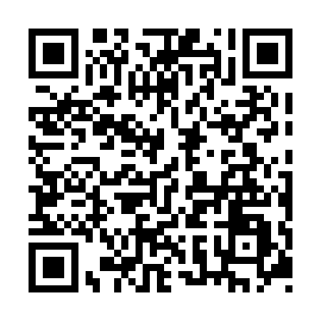
Prayer times for Aminapiskasich, Quebec, Canada
Wed 1 May 2024 - Fri 31 May 2024
High Latitude Method: Angle Based Rule
Prayer Calculation Method: Islamic Society of North America
Asar Calculation Method: Hanafi

Date | Day | Fajr | Sunrise | Dhuhr | Asr | Maghrib | Isha
1 | Wed | 3:42 | 5:42 | 1:11 | 6:19 | 8:41 | 10:42
2 | Thu | 3:39 | 5:41 | 1:11 | 6:20 | 8:42 | 10:44
3 | Fri | 3:36 | 5:39 | 1:11 | 6:22 | 8:44 | 10:47
4 | Sat | 3:33 | 5:37 | 1:11 | 6:23 | 8:46 | 10:50
5 | Sun | 3:30 | 5:35 | 1:11 | 6:24 | 8:47 | 10:53
6 | Mon | 3:27 | 5:33 | 1:11 | 6:25 | 8:49 | 10:56
7 | Tue | 3:24 | 5:31 | 1:11 | 6:26 | 8:51 | 10:59
8 | Wed | 3:21 | 5:30 | 1:11 | 6:26 | 8:52 | 11:02
9 | Thu | 3:19 | 5:28 | 1:11 | 6:27 | 8:54 | 11:02
10 | Fri | 3:19 | 5:26 | 1:11 | 6:28 | 8:56 | 11:03
11 | Sat | 3:18 | 5:25 | 1:11 | 6:29 | 8:57 | 11:04
12 | Sun | 3:17 | 5:23 | 1:10 | 6:30 | 8:59 | 11:05
13 | Mon | 3:16 | 5:21 | 1:10 | 6:31 | 9:00 | 11:06
14 | Tue | 3:15 | 5:20 | 1:10 | 6:32 | 9:02 | 11:06
15 | Wed | 3:15 | 5:18 | 1:11 | 6:33 | 9:03 | 11:07
16 | Thu | 3:14 | 5:17 | 1:11 | 6:34 | 9:05 | 11:08
17 | Fri | 3:13 | 5:15 | 1:11 | 6:35 | 9:07 | 11:09
18 | Sat | 3:12 | 5:14 | 1:11 | 6:36 | 9:08 | 11:09
19 | Sun | 3:12 | 5:13 | 1:11 | 6:37 | 9:09 | 11:10
20 | Mon | 3:11 | 5:11 | 1:11 | 6:37 | 9:11 | 11:11
21 | Tue | 3:11 | 5:10 | 1:11 | 6:38 | 9:12 | 11:12
22 | Wed | 3:10 | 5:09 | 1:11 | 6:39 | 9:14 | 11:12
23 | Thu | 3:09 | 5:07 | 1:11 | 6:40 | 9:15 | 11:13
24 | Fri | 3:09 | 5:06 | 1:11 | 6:41 | 9:16 | 11:14
25 | Sat | 3:08 | 5:05 | 1:11 | 6:42 | 9:18 | 11:15
26 | Sun | 3:08 | 5:04 | 1:11 | 6:42 | 9:19 | 11:15
27 | Mon | 3:07 | 5:03 | 1:11 | 6:43 | 9:20 | 11:16
28 | Tue | 3:07 | 5:02 | 1:12 | 6:44 | 9:22 | 11:17
29 | Wed | 3:06 | 5:01 | 1:12 | 6:44 | 9:23 | 11:17
30 | Thu | 3:06 | 5:00 | 1:12 | 6:45 | 9:24 | 11:18
31 | Fri | 3:06 | 4:59 | 1:12 | 6:46 | 9:25 | 11:19
Prayer times provided by https://www.salahtimes.com

