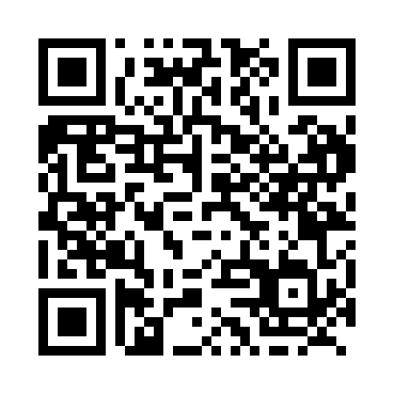
Prayer times for Vallican, British Columbia, Canada
Wed 1 May 2024 - Fri 31 May 2024
High Latitude Method: Angle Based Rule
Prayer Calculation Method: Islamic Society of North America
Asar Calculation Method: Hanafi

Date | Day | Fajr | Sunrise | Dhuhr | Asr | Maghrib | Isha
1 | Wed | 3:38 | 5:27 | 12:48 | 5:53 | 8:09 | 9:58
2 | Thu | 3:36 | 5:25 | 12:48 | 5:54 | 8:11 | 10:01
3 | Fri | 3:33 | 5:23 | 12:47 | 5:55 | 8:12 | 10:03
4 | Sat | 3:31 | 5:22 | 12:47 | 5:56 | 8:14 | 10:05
5 | Sun | 3:28 | 5:20 | 12:47 | 5:57 | 8:15 | 10:08
6 | Mon | 3:26 | 5:19 | 12:47 | 5:58 | 8:17 | 10:10
7 | Tue | 3:23 | 5:17 | 12:47 | 5:58 | 8:18 | 10:12
8 | Wed | 3:21 | 5:15 | 12:47 | 5:59 | 8:19 | 10:15
9 | Thu | 3:18 | 5:14 | 12:47 | 6:00 | 8:21 | 10:17
10 | Fri | 3:16 | 5:12 | 12:47 | 6:01 | 8:22 | 10:20
11 | Sat | 3:13 | 5:11 | 12:47 | 6:02 | 8:24 | 10:22
12 | Sun | 3:11 | 5:09 | 12:47 | 6:03 | 8:25 | 10:24
13 | Mon | 3:08 | 5:08 | 12:47 | 6:04 | 8:27 | 10:27
14 | Tue | 3:06 | 5:07 | 12:47 | 6:04 | 8:28 | 10:29
15 | Wed | 3:04 | 5:05 | 12:47 | 6:05 | 8:29 | 10:32
16 | Thu | 3:01 | 5:04 | 12:47 | 6:06 | 8:31 | 10:34
17 | Fri | 2:59 | 5:03 | 12:47 | 6:07 | 8:32 | 10:37
18 | Sat | 2:56 | 5:01 | 12:47 | 6:08 | 8:33 | 10:39
19 | Sun | 2:54 | 5:00 | 12:47 | 6:08 | 8:35 | 10:41
20 | Mon | 2:53 | 4:59 | 12:47 | 6:09 | 8:36 | 10:42
21 | Tue | 2:53 | 4:58 | 12:47 | 6:10 | 8:37 | 10:42
22 | Wed | 2:52 | 4:57 | 12:47 | 6:11 | 8:39 | 10:43
23 | Thu | 2:52 | 4:56 | 12:47 | 6:11 | 8:40 | 10:44
24 | Fri | 2:51 | 4:55 | 12:48 | 6:12 | 8:41 | 10:44
25 | Sat | 2:51 | 4:54 | 12:48 | 6:13 | 8:42 | 10:45
26 | Sun | 2:50 | 4:53 | 12:48 | 6:14 | 8:43 | 10:46
27 | Mon | 2:50 | 4:52 | 12:48 | 6:14 | 8:44 | 10:46
28 | Tue | 2:50 | 4:51 | 12:48 | 6:15 | 8:46 | 10:47
29 | Wed | 2:49 | 4:50 | 12:48 | 6:16 | 8:47 | 10:47
30 | Thu | 2:49 | 4:49 | 12:48 | 6:16 | 8:48 | 10:48
31 | Fri | 2:49 | 4:49 | 12:48 | 6:17 | 8:49 | 10:49
Prayer times provided by https://www.salahtimes.com

